CHAPTER I
INTRODUCTION
Technical Background
In the digital age, effective assist research project management relies heavily on advanced technological infrastructures that support coordination, tracking, and evaluation of research activities. Research remains a cornerstone of higher education institutions worldwide, acting as a driver for knowledge advancement, innovation, and societal development (Smith & Johnson, 2023). Globally, universities are transitioning from manual processes to integrated digital platforms that enable real-time collaboration, automated workflows, and data-driven decision-making. These technologies are essential for competitiveness, compliance with international research standards, and impactful academic outputs.
In the Philippines, research management in higher education is shaped by national policy frameworks that emphasize structured and efficient administration. The Commission on Higher Education (CHED) Memorandum Order No. 15, Series of 2016, sets the Research Agenda for Higher Education Institutions and highlights the necessity for robust research systems (CHED, 2016). Republic Act No. 7687, the "Science and Technology Scholarship Act," mandates thorough documentation of research activities, while the Department of Science and Technology (DOST) outlines guidelines for monitoring and evaluating academic research. These policies underline the need for systems that ensure transparency, accountability, and strategic research administration.
Despite these frameworks, many universities in the Philippines, including the University of Eastern Philippines (UEP), face persistent challenges due to outdated and fragmented systems. Common issues include long approval timelines, limited communication between stakeholders, ineffective tracking of research progress, and difficulties in managing research documentation. While research data is stored in one place, inefficiencies in system design and access make it difficult to compile reports, evaluate outcomes, and align projects with institutional goals. These inefficiencies significantly impact both individual research projects and the institution's overall research capabilities.
These inefficiencies significantly impact both individual research projects and the institution's overall research capabilities.
A web-based application is proposed as a solution to address these challenges. Web systems offer multi-device accessibility, allowing users to interact with the platform through any browser-enabled device, enhancing flexibility and convenience. Platform independence supports usage across desktops, laptops, and mobile devices, while centralized maintenance ensures that all users benefit from real-time updates. However, potential limitations include reliance on stable internet connectivity and the complexity of designing a consistent user interface across platforms (Kumar & Patel, 2024). Still, a web-based approach offers significant promise in improving UEP's research operations.
The researchers were motivated to design a system that balances innovation with practical constraints, including time, budget, and technical capacity. Designing such a system requires close coordination with faculty and administrators to ensure that the platform aligns with existing workflows. Usability is another important factor—training and support will be critical to ensure that all users, from researchers to system administrators, can navigate and utilize the platform effectively.
Security and privacy are also key concerns in handling sensitive academic data. Protecting user information, research documents, and submission records requires robust security features. The system is designed to incorporate encryption, role-based access controls, and secure authentication mechanisms to protect sensitive data (Johnson et al., 2024). These features support a secure and trustworthy research environment.
Emerging technologies such as process automation, artificial intelligence, and cloud computing may offer future enhancements. These technologies can be explored in subsequent iterations of the system to further increase efficiency and analytic capabilities in research project management.

Purpose and Description of the Project
This project aims to improve the University of Eastern Philippines' research management processes through the design of a web-based Assist Research Project Management System (ARPMS). The ARPMS is intended to streamline core research activities such as proposal submission, project tracking, document management, and reporting. It will incorporate distinct user roles—Researchers, Research Supervisors, Coordinators, Department Heads, and System Administrators—to enable effective communication and collaboration. Ultimately, the system is designed to increase efficiency, transparency, and academic productivity at UEP (Lopez & Reyes, 2024).
The project emphasizes a user-centered approach in designing the ARPMS to meet the specific needs of its users. Role-specific access and clearly defined responsibilities will enhance workflow coordination and ensure that research activities are managed systematically and efficiently. The ARPMS aims to support UEP in transitioning to a digital research ecosystem that upholds excellence and fosters innovation.

Objectives of the Project
This project aims to design a comprehensive Research Project Management System that enhances project documentation, coordination, and tracking within the University of Eastern Philippines. Specifically, it seeks to:
- To design and develop the ARPMS following Agile system development methodology.
- To design and develop the ARPMS to include the following core functionalities:
2.1. Digital repository management
2.2. Project timeline and milestone tracking
2.3. Proposal and progress submission
2.4. Automated workflow management
2.5. Collaboration and communication tools
2.6. Budget Monitoring and Management
Determine the level of acceptability of the ARPMS in terms of:
3.1. Performance
3.2. Information
3.3. Efficiency
3.4. Control and security
3.5. Economics
3.6. Services

Scope of the Project
This project covers the design of the Assist Research Project Management System (ARPMS), a web-based platform developed to support the research operations of the University of Eastern Philippines in Northern Samar. The system is intended to improve research documentation, approval processes, milestone tracking, and collaboration.

Functionalities
The ARPMS includes the following functionalities:
- Digital repository management
- Proposal submission and digital review
- Real-time progress and milestone tracking
- Internal communication and collaboration tools
- Budget documentation and funding application tracking

Geographic Unit
The system will be deployed within UEP-Main campus in Catarman, Northern Samar. While the platform is tailored to the unique needs of UEP-Main, its design and framework may offer insights for other academic institutions seeking to improve their research management processes.
Limitations
The Assist Research Project Management System (ARPMS) is designed primarily for internal use within the University and is optimized for web access through standard browsers. It does not include native mobile applications and may have limited functionality on smaller mobile devices. Additionally, the system currently focuses on managing internal research processes and does not provide features for collaboration with external institutions or researchers.

Significance of the Project
This project offers significant benefits to the following stakeholders:
- Faculty and Employee Researchers: Enhanced accuracy and efficiency in research tracking and submission.
- Research Coordinators and Supervisors: Improved project oversight and streamlined approvals.
- Department Heads: Better project management and resource monitoring.
- Students: User-friendly system for submitting and managing research activities.
- University of Eastern Philippines: Improved research productivity and digital innovation.

DEFINITION OF TERMS
This section presents the key terms used in the study, defined both conceptually and operationally.

Assist Research Project Management System (ARPMS)
Conceptual: A digital system used to coordinate, manage, and monitor research activities, including proposal submissions, collaboration, resource management, and reporting across an academic institution (Torres & Ramirez, 2022). Operational: The web-based system developed to streamline research workflows, automate processes, and centralize project data at the University of Eastern Philippines.

Automated Workflow
Conceptual: A technology-enabled process that automatically routes tasks and approvals to relevant individuals based on predefined rules (Villanueva, 2023). Operational: A built-in ARPMS feature that facilitates the automated review, approval, and escalation of research proposals and progress reports.

Collaboration Tools
Conceptual: Integrated software tools designed to support communication and teamwork among researchers and project members (Cruz & Mendoza, 2020). Operational: In ARPMS, this includes internal messaging, shared document editing, and file upload functions to support research collaboration at UEP.

Control and Security
Conceptual: The systematic implementation of access restrictions, data protection measures, and system safeguards to maintain information integrity and prevent unauthorized access (NIST, 2020). Operational: ARPMS features including role-based access controls, data encryption protocols, automated backup systems, and audit trails to protect research data and ensure system security at UEP.

Digital Repository
Conceptual: A secure digital storage system where documents and data can be stored, managed, and retrieved for long-term access (Gonzaga, 2022). Operational: The feature in ARPMS that stores proposals, progress reports, and research documents in a centralized and secure manner.

Economics
Conceptual: The evaluation of financial benefits, cost savings, and resource optimization achieved through system implementation and operation (Santiago & Tan, 2020). Operational: The cost-effectiveness analysis of ARPMS implementation at UEP, measuring reduced administrative costs, time savings, and improved resource allocation in research management processes.

Efficiency
Conceptual: The capability of a system to accomplish tasks with minimal waste of time, effort, and resources while maximizing productivity (ISO, 2020). Operational: ARPMS functionality that streamlines research processes, reduces paperwork requirements, and optimizes workflows for UEP stakeholders through automated procedures and integrated tools.

Information
Conceptual: The quality, accuracy, completeness, and accessibility of data processed and presented by a system (Lorenzo & Santos, 2022). Operational: ARPMS capability to provide accurate, complete, and easily accessible research data, reports, and documentation to UEP users in real-time with proper formatting and relevance.

Information System
Conceptual: A structured combination of people, processes, and technology for managing and processing information (Lorenzo & Santos, 2022). Operational: The ARPMS, as the primary information system for research operations at the University of Eastern Philippines.

Management System
Conceptual: A structured framework consisting of processes, practices, and tools used to manage and coordinate tasks, data, and resources to meet organizational goals efficiently (ISO, 2020; Lorenzo & Santos, 2022). Operational: The ARPMS itself—designed as a web-based management system to automate and coordinate research processes, tasks, documentation, and reporting across departments at UEP.

Performance
Conceptual: The measure of a system's speed, reliability, responsiveness, and overall operational effectiveness in executing tasks and delivering results (Bautista & Corpuz, 2021). Operational: ARPMS system metrics including response time, uptime reliability, processing speed, and consistent functionality performance as experienced by UEP users during research management activities.

PIECES Framework
Conceptual: A system evaluation model focused on six dimensions: Performance, Information, Economics, Control, Efficiency, and Service (Bautista & Corpuz, 2021). Operational: The framework used to assess the ARPMS's impact on research management at UEP.

Progress Monitoring
Conceptual: The regular assessment of project milestones, deliverables, and timelines to ensure alignment with objectives and timely completion (Reyes & Santos, 2021). Operational: The ARPMS module that provides UEP stakeholders with real-time tracking of research progress, deadlines, and status updates.

Proposal Submission
Conceptual: The formal presentation of a research idea, methodology, and resource request to an authority or institution for evaluation and approval (Del Rosario, 2023). Operational: The ARPMS function allowing UEP researchers to digitally submit proposals to supervisors and committees for review.

Research Funding Management
Conceptual: The planning, budgeting, and monitoring of financial resources dedicated to academic research (Santiago & Tan, 2020). Operational: The ARPMS feature used to record, review, and track funding applications and budget allocations for UEP research projects.

Role-Based Access Control (RBAC)
Conceptual: A security model that restricts user access to system resources based on their role or responsibility within an organization (NIST, 2020). Operational: A security feature in ARPMS that assigns permissions to UEP users such as researchers, supervisors, and administrators.

Security Protocols
Conceptual: Standards and technologies used to protect digital information and ensure secure data transfer and access (Dela Cruz, 2022). Operational: The security measures within ARPMS including encrypted connections, secure login authentication, and access logging.

Services
Conceptual: The quality of user experience, support mechanisms, and functional capabilities provided by a system to meet user needs and expectations (Lopez & Reyes, 2024). Operational: ARPMS user experience features including intuitive interface design, help documentation, technical support availability, and comprehensive functionality that serves UEP stakeholders' research management requirements.

Stakeholders
Conceptual: All individuals or entities who have an interest in the outcomes of a research project, including funders, researchers, and administrators (Lopez & Javier, 2021). Operational: Researchers, supervisors, department heads, and administrators at UEP who use or rely on the ARPMS for research management.

System Acceptability
Conceptual: The degree to which users find a system functional, efficient, and easy to use, typically evaluated using models like PIECES (Lopez & Reyes, 2024). Operational: UEP stakeholder perceptions of ARPMS in terms of usability, usefulness, reliability, and performance.

System Administrator
Conceptual: A technical user responsible for managing system configurations, users, and overall software maintenance (Cabrera, 2023). Operational: The ARPMS user at UEP tasked with managing user accounts, permissions, system settings, and maintenance tasks.

Timeline and Milestone Tracking
Conceptual: The monitoring of scheduled phases and tasks to ensure project goals are met on time (Diaz & Francisco, 2021). Operational: ARPMS functionality that lets UEP users define and track important dates, milestones, and project completion stages.

User Roles
Conceptual: Defined user types within a system that determine access levels, responsibilities, and available functions (Tecson & Lim, 2020). Operational: ARPMS user categories such as Researcher, Research Supervisor, Coordinator, Department Head, and Administrator.

Version Control
Conceptual: A process of managing document revisions and updates, allowing users to track changes and revert to previous versions (Aguila & Ramos, 2022). Operational: ARPMS feature that stores and tracks document changes to ensure the most recent and accurate versions are used in project development.

Web-Based System
Conceptual: A software system that operates over the internet and can be accessed via web browsers without local installation (Design developer, 2022). Operational: The platform design of ARPMS, allowing UEP users to access it on any browser-equipped device.

Chapter II
REVIEW OF LITERATURE AND STUDIES
Relevant Literature
Assist Research project management systems (ARPMS) have undergone significant evolution to address the unique challenges of research environments. According to Turner and Müller (2005), effective research project management requires specialized approaches that balance scientific rigor with administrative efficiency. Their comprehensive analysis emphasized that research projects differ from conventional projects due to their inherent uncertainty, iterative nature, and focus on knowledge creation rather than predefined deliverables. The study noted that modern ARPMS must accommodate these distinctive characteristics while providing sufficient structure to ensure accountability, resource optimization, and timely completion (Turner & Müller, 2005).
The integration of digital technologies into research project management has transformed how academic and industrial research is coordinated and executed. Verner et al. (2014) conducted a comprehensive review of digital research management platforms, finding that cloud-based systems offer significant advantages in terms of accessibility, collaboration, and data security. Their analysis revealed that institutions implementing integrated assist research project management systems reported substantial improvements in cross-disciplinary collaboration and administrative efficiency. The study also identified key features of successful ARPMS, including customizable workflows, automated compliance checking, and seamless integration with institutional research information systems (Verner et al., 2014).
A systematic review of research project governance frameworks by Pollack et al. (2013) examined how project management principles are adapted for research contexts. The review identified several critical success factors for research projects, including clear alignment with strategic objectives, appropriate stakeholder engagement, and balanced oversight that provides accountability without restricting scientific creativity. The authors found that effective assist research project management systems incorporate governance mechanisms that address the unique ethical considerations, funding constraints, and publication requirements inherent in research activities. The study also emphasized the importance of knowledge management capabilities within ARPMS to capture insights and lessons learned (Pollack et al., 2013).
Joslin and Müller (2015) explored the relationship between assist research project management systems and research impact through their comprehensive analysis of project management paradigms. Their findings demonstrated that organizations with mature project management frameworks achieved significantly higher success rates compared to those with ad hoc management approaches. The study identified critical components that contributed to these outcomes, including structured milestone planning, systematic risk assessment, and integrated performance metrics. The authors emphasized that effective assist research project management systems not only improve operational efficiency but also enhance the quality and influence of research outputs (Joslin & Müller, 2015).
The adaptation of agile methodologies for research project management has gained attention in recent literature. Conforto et al. (2014) analyzed the application of agile principles in diverse research settings through their systematic literature review, finding that iterative planning and regular reflection sessions significantly improved research teams' ability to adapt to emerging findings and changing priorities. Their study indicated that research projects employing agile-inspired management approaches demonstrated enhanced flexibility and responsiveness without compromising scientific quality. The authors proposed frameworks that combine the flexibility of agile with the structure of traditional project management, specifically designed for research environments (Conforto et al., 2014).
Spalek (2014) examined the role of information technology in enhancing assist research project management systems through a comprehensive analysis of IT tools and applications. The review identified several promising areas for technology integration, including automated project tracking, resource allocation optimization, and collaborative platforms for distributed research teams. The study found that IT-enhanced project management systems reduced administrative workload and improved project coordination capabilities compared to conventional systems. However, the author cautioned that successful technology integration requires careful attention to user acceptance, system compatibility, and organizational readiness (Spalek, 2014).
A comprehensive bibliometric analysis by Papke-Shields and Boyer-Wright (2017) mapped the evolution of project management research over several decades. The study analyzed extensive publication databases, identifying major developmental phases in project management theory and practice. The authors noted significant growth in publications focused on specialized project management applications during recent periods, reflecting growing recognition of project management as a critical organizational capability. The analysis also revealed variations in research focus across different regions and institutional contexts (Papke-Shields & Boyer-Wright, 2017).
Biedenbach and Müller (2012) investigated the relationship between project management and innovation outcomes in research-intensive organizations. Their study found that comprehensive project management systems facilitated effective coordination and knowledge sharing, leading to more innovative research outcomes. The authors identified specific features that supported innovative work, including flexible planning processes, cross-functional communication tools, and integrated knowledge management capabilities. The research emphasized that as scientific challenges become increasingly complex, effective project management systems will be essential for coordinating interdisciplinary research efforts (Biedenbach & Müller, 2012).
The role of stakeholder engagement in research project management has been examined by Eskerod and Jepsen (2013) through their analysis of stakeholder management practices across different project contexts. Their study found that projects with robust stakeholder identification and engagement capabilities reported higher rates of successful outcomes and practical application of results. The authors identified systematic approaches to stakeholder management as critical success factors for impactful research projects. The study highlighted the importance of project management features that facilitate bidirectional communication with stakeholders throughout the project lifecycle (Eskerod & Jepsen, 2013).
A comparative analysis of project management approaches across different organizational contexts was conducted by Gemünden et al. (2005). The study found significant variations in project management implementation across sectors, with different emphases on efficiency, innovation, and stakeholder engagement depending on organizational goals and constraints. Despite these differences, the authors identified common success factors, including clear strategic alignment, appropriate governance structures, and balanced performance measurement systems. The research concluded that context-sensitive project management design is essential, with frameworks tailored to specific organizational environments and objectives (Gemünden et al., 2005).
In the Philippine context, Santos and Dela Cruz (2020) examined the evolution of research project management practices in higher education institutions across the archipelago. Their comprehensive study analyzed project management implementation in 45 universities, finding that institutions with formal research management systems demonstrated significantly higher research output and funding acquisition rates. The study identified unique challenges in the Philippine context, including limited technological infrastructure, varying institutional capacities, and the need for culturally-sensitive management approaches. The authors emphasized that successful research project management in the Philippines requires adaptation of international best practices to local contexts while maintaining quality standards (Santos & Dela Cruz, 2020).
Research conducted by Reyes et al. (2021) at the University of the Philippines system investigated the impact of digital transformation on research project management across multiple campuses. The study found that UP campuses implementing integrated research management platforms experienced substantial improvements in inter-campus collaboration and research coordination. The research highlighted the importance of technology adoption in overcoming geographical barriers common in archipelagic settings and emphasized the role of institutional support in successful system implementation. The findings demonstrated that effective assist research project management systems must address the unique logistical challenges faced by Philippine universities (Reyes et al., 2021).
A regional study by Magbanua and Torres (2022) examined research project management practices specifically in Visayas-based universities, including institutions from Iloilo, Cebu, and Leyte. The research documented varying levels of research management sophistication across the region, with state universities generally showing more advanced systems compared to private institutions. The study identified regional collaboration opportunities and emphasized the potential for shared research management resources among Visayas universities. The authors noted that effective research management in the region requires consideration of local research priorities, including marine sciences, agriculture, and disaster risk reduction (Magbanua & Torres, 2022).
Specifically focusing on Northern Samar, research by Villanueva (2023) analyzed the research management capabilities of local higher education institutions, including the University of Eastern Philippines and Northwest Samar State University. The study found that while these institutions face resource constraints, they have developed innovative approaches to research project management that leverage community partnerships and regional networks. The research emphasized the importance of context-appropriate management systems that support the unique research agenda of Northern Samar institutions, particularly in areas of rural development, marine resource management, and disaster preparedness (Villanueva, 2023).

Related Studies
A dissertation by Miller (2018) examined the implementation of comprehensive assist research project management systems at major research universities through multiple case study analysis. The study documented significant improvements in research productivity and compliance across the institutions studied. Universities that deployed integrated platforms combining project planning, budget management, and collaboration features showed substantial improvements in grant submission success rates and reductions in administrative delays. Researchers reported that automated systems for deadline and compliance tracking allowed greater focus on scientific activities while maintaining administrative rigor. The study emphasized the importance of stakeholder consultation during system design and phased implementation approaches (Miller, 2018).
Thompson's doctoral dissertation (2019) provided a comparative analysis of assist research project management systems across pharmaceutical research organizations. The study demonstrated that customized project management solutions outperformed generic tools in supporting drug discovery and development processes. Organizations using domain-specific systems reported faster milestone achievement and more efficient resource utilization. The research identified critical features for pharmaceutical research management, including integrated regulatory compliance workflows and clinical trial management capabilities. The author emphasized that effective systems must balance standardization with flexibility to accommodate scientific uncertainty (Thompson, 2019).
A thesis by Rodriguez (2020) evaluated the impact of technology-enhanced project management systems on collaborative research projects through experimental design. The study incorporated advanced analytics to predict resource requirements and optimize team compositions based on expertise matching. Results showed substantial improvements in timeline forecasting accuracy and reductions in resource allocation conflicts compared to traditional management approaches. The research found that predictive capabilities improved over time as systems accumulated project data, demonstrating the value of organizational learning in research management (Rodriguez, 2020).
Davis's master's thesis (2021) presented a longitudinal study of assist research project management system adoption in climate research institutes, tracking outcomes over multiple years following implementation. The institutes implemented cloud-based systems with specialized features for managing distributed research teams and large datasets. The study documented substantial improvements, including increased cross-institutional collaborations, reduced project delays, and enhanced data sharing between research groups. However, the author also identified challenges including initial user resistance and technical integration issues with legacy systems (Davis, 2021).
A doctoral study by Chen (2019) examined assist research project management system implementation across university departments using mixed-methods approaches. The research found that departments with fully integrated project management systems reported significantly higher research output and improved operational efficiency compared to those with fragmented systems. Quantitative analysis revealed strong correlations between system maturity and various performance indicators, including publication rates and funding success. Qualitative interviews identified critical success factors including leadership support, adequate training resources, and alignment with disciplinary practices (Chen, 2019).
Martinez's thesis (2020) documented an action research project conducted at research hospitals focusing on clinical research project management. The study addressed specific challenges in clinical research environments, including patient recruitment tracking and regulatory compliance coordination. Over the implementation period, hospitals reported substantial improvements in patient recruitment rates, reductions in regulatory submission errors, and decreased protocol deviations. The research emphasized the importance of engaging frontline staff in system design and highlighted the value of real-time visibility into study progress (Martinez, 2020).
A master's thesis by Johnson (2021) surveyed research project managers across diverse scientific fields to investigate relationships between project management system capabilities and outcomes. The study found that communication and knowledge management features were most strongly associated with project success, followed by risk management and resource planning capabilities. The research revealed that system sophistication alone did not predict success; rather, alignment between system capabilities and research contexts was the determining factor. Projects with high uncertainty benefited most from flexible, communication-focused systems (Johnson, 2021).
Kim's doctoral dissertation (2018) provided an ethnographic study of research project management practices in genomics research institutes, offering insights into how formal systems interact with organizational cultures. The researcher conducted extensive fieldwork, observing how management systems were used in daily practice. Findings revealed that while comprehensive project management systems provided essential structure, effective research management also depended on informal knowledge sharing and adaptive leadership. The study identified ways that successful research leaders used formal systems while encouraging scientific creativity and autonomy (Kim, 2018).
A technical case study thesis by Anderson (2019) detailed the development of integrated assist research project management systems for space science missions. The study examined systems combining traditional project management functionality with specialized features for managing complex scientific instrumentation and international partnerships. Implementation results showed substantial improvements in cross-team coordination and reductions in technical integration issues. The case study highlighted unique requirements for research project management in high-reliability contexts, including comprehensive risk management and knowledge preservation across extended project lifecycles (Anderson, 2019).
Wilson's doctoral dissertation (2020) provided a comparative analysis of assist research project management systems in pharmaceutical companies, examining how system functionality affects drug discovery and development outcomes. Companies with highly integrated systems connecting research data management and project management tools demonstrated faster progression from discovery to clinical testing and higher regulatory approval success rates. The study identified critical success factors, including seamless information flow between systems, balanced performance metrics, and governance structures maintaining scientific integrity while ensuring strategic alignment (Wilson, 2020).
A Philippine-based doctoral study by Mercado (2021) examined the implementation of assist research project management systems in state universities across the Philippines. The research utilized mixed-methods approaches to analyze system adoption patterns, implementation challenges, and outcomes across 25 institutions. The study found that universities with comprehensive research management systems reported significantly higher research productivity, improved grant acquisition rates, and enhanced institutional research capacity. The author identified critical success factors specific to the Philippine context, including strong institutional leadership, adequate technological infrastructure, and alignment with national research priorities (Mercado, 2021).
Research conducted through the University of the Philippines Visayas by Cruz (2022) provided an in-depth analysis of research project management practices in marine science research institutions across the Visayas region. The study documented implementation experiences at UPV and other regional institutions, finding that specialized research management systems for marine sciences yielded substantial improvements in field research coordination, data management, and inter-institutional collaboration. The research emphasized the unique requirements for managing marine research projects, including equipment tracking, weather-dependent scheduling, and compliance with maritime regulations (Cruz, 2022).
A master's thesis by Fernandez (2023) conducted at Visayas State University examined the relationship between assist research project management systems and agricultural research outcomes in the region. The study analyzed research projects conducted across multiple VSU campuses, finding that systematic project management approaches led to more successful technology transfer to farming communities and improved research impact measurement. The research identified specific challenges in agricultural research management, including seasonal variations, field site coordination, and stakeholder engagement with farming communities. The author recommended integrated approaches that combine traditional project management with community-based participatory research methods (Fernandez, 2023).

Table 1

Summary of Related Literature and Studies
Year | Author/s | Title | Journal Name | Topic/Research  Question/Objectives | Theory/ries
2022 | Aguilar, M. R. | Development and implementation of ARPMS... | University of Eastern Philippines | ARPMS in resource-limited HEIs | Project Implementation Models
Findings | Gaps/Recommendation | Origin/Country (local/Foreign) | Method/Methodology | Respondent/s or Client of the System Development | Remarks
Improved coordination & monitoring | Need scalable systems | Philippines | Case Study | HEI Faculty/Admin | Local
Year | Author/s | Title | Journal Name | Topic/Research  Question/Objectives | Theory/ries
2019 | Anderson, M. J. | Integrated PM systems for space missions | MIT | PM system integration in complex env | Systems Integration Theory
Findings | Gaps/Recommendation | Origin/Country (local/Foreign) | Method/Methodology | Respondent/s or Client of the System Development | Remarks
Reduced risks, improved success | Limited to high-resource contexts | USA | Qualitative Analysis | NASA Teams | Foreign
Year | Author/s | Title | Journal Name | Topic/Research  Question/Objectives | Theory/ries
2012 | Biedenbach & Müller | Impact of capabilities on project performance | Int’l Journal of Project Management | Effect of adaptive capabilities | Dynamic Capability Theory
Findings | Gaps/Recommendation | Origin/Country (local/Foreign) | Method/Methodology | Respondent/s or Client of the System Development | Remarks
Adaptive capability improves success | More studies needed in HEIs | Sweden | Quantitative | Project Managers | Foreign
Year | Author/s | Title | Journal Name | Topic/Research  Question/Objectives | Theory/ries
2019 | Chen, L. | ARPMS in university departments | Stanford University | Challenges in ARPMS adoption | Org. Change Theory
Findings | Gaps/Recommendation | Origin/Country (local/Foreign) | Method/Methodology | Respondent/s or Client of the System Development | Remarks
Resistance affects success | Change management needed | USA | Mixed Methods | Faculty/Admin | Foreign
Year | Author/s | Title | Journal Name | Topic/Research  Question/Objectives | Theory/ries
2014 | Conforto et al. | Agile PM in traditional industries | Project Management Journal | Adoption of agile methods | Agile Theory
Findings | Gaps/Recommendation | Origin/Country (local/Foreign) | Method/Methodology | Respondent/s or Client of the System Development | Remarks
Applicable beyond software | Research public sector | Brazil | Survey & Case Study | Industry Teams | Foreign
Year | Author/s | Title | Journal Name | Topic/Research  Question/Objectives | Theory/ries
2022 | Cruz, A. L. | ARPMS practices in marine science institutions | UP Visayas | Marine science ARPMS usage | Project Life Cycle
Findings | Gaps/Recommendation | Origin/Country (local/Foreign) | Method/Methodology | Respondent/s or Client of the System Development | Remarks
Fragmented practices | Promote unified ARPMS | Philippines | Case Study | Marine Science Researchers | Local
Year | Author/s | Title | Journal Name | Topic/Research  Question/Objectives | Theory/ries
2021 | Davis, R. | Longitudinal ARPMS adoption in climate institutes | UC Berkeley | Adoption trends over time | Innovation Diffusion
Findings | Gaps/Recommendation | Origin/Country (local/Foreign) | Method/Methodology | Respondent/s or Client of the System Development | Remarks
Increased with funding | Recommend support & training | USA | Longitudinal Study | Climate Researchers | Foreign
Year | Author/s | Title | Journal Name | Topic/Research  Question/Objectives | Theory/ries
2013 | Eskerod & Jepsen | Project stakeholder management | Gower Publishing | Managing expectations in PM | Stakeholder Theory
Findings | Gaps/Recommendation | Origin/Country (local/Foreign) | Method/Methodology | Respondent/s or Client of the System Development | Remarks
Engagement aligns projects | Needs study in HEI context | Denmark | Literature Review | PM Teams | Foreign
Year | Author/s | Title | Journal Name | Topic/Research  Question/Objectives | Theory/ries
2023 | Fernandez, J. P. | ARPMS & agricultural research in Visayas | Visayas State University | ARPMS effects on agriculture | Input-Output Model
Findings | Gaps/Recommendation | Origin/Country (local/Foreign) | Method/Methodology | Respondent/s or Client of the System Development | Remarks
Positive impact | Expand infrastructure | Philippines | Mixed Methods | Agri Researchers | Local
Year | Author/s | Title | Journal Name | Topic/Research  Question/Objectives | Theory/ries
2005 | Gemünden et al. | Project-oriented company & innovation | Int’l Journal of Project Management | Project-based innovation | Organizational Capability
Findings | Gaps/Recommendation | Origin/Country (local/Foreign) | Method/Methodology | Respondent/s or Client of the System Development | Remarks
Enhances adaptability | Study in HEI context needed | Germany | Quantitative | Corporate Teams | Foreign
Year | Author/s | Title | Journal Name | Topic/Research  Question/Objectives | Theory/ries
2021 | Johnson, K. | ARPMS outcomes across disciplines | University of Michigan | Effectiveness of ARPMS by field | Capability Maturity
Findings | Gaps/Recommendation | Origin/Country (local/Foreign) | Method/Methodology | Respondent/s or Client of the System Development | Remarks
Improves consistency | Share best practices | USA | Survey | Researchers | Foreign
Year | Author/s | Title | Journal Name | Topic/Research  Question/Objectives | Theory/ries
2015 | Joslin & Müller | PM methodology & project success | Int’l Journal of Project Management | Methods vs success by context | Contingency Theory
Findings | Gaps/Recommendation | Origin/Country (local/Foreign) | Method/Methodology | Respondent/s or Client of the System Development | Remarks
Context-sensitive PM works best | Apply to HEIs | Norway | Quantitative | Corporate PMs | Foreign
Year | Author/s | Title | Journal Name | Topic/Research  Question/Objectives | Theory/ries
2018 | Kim, S. | Ethnographic study of ARPMS | Harvard University | Everyday ARPMS practices | Grounded Theory
Findings | Gaps/Recommendation | Origin/Country (local/Foreign) | Method/Methodology | Respondent/s or Client of the System Development | Remarks
Informal practices dominate | Formalize but retain flexibility | USA | Ethnographic | Genomics Staff | Foreign
Year | Author/s | Title | Journal Name | Topic/Research  Question/Objectives | Theory/ries
2022 | Magbanua & Torres | ARPMS in Visayas universities | PJHER | Collaboration opportunities | Collaboration Theory
Findings | Gaps/Recommendation | Origin/Country (local/Foreign) | Method/Methodology | Respondent/s or Client of the System Development | Remarks
Underutilized collaboration | Build shared platform | Philippines | Descriptive | HEI Admin | Local
Year | Author/s | Title | Journal Name | Topic/Research  Question/Objectives | Theory/ries
2020 | Martinez, C. | Action research on ARPMS | University of Toronto | Implementation process | Action Research
Findings | Gaps/Recommendation | Origin/Country (local/Foreign) | Method/Methodology | Respondent/s or Client of the System Development | Remarks
Iterative design boosts adoption | Apply in other settings | Canada | Action Research | Clinical Staff | Foreign
Year | Author/s | Title | Journal Name | Topic/Research  Question/Objectives | Theory/ries
2021 | Mercado, E. S. | ARPMS in PH state universities | UP Diliman | ARPMS challenges & outcomes | Org. Change Theory
Findings | Gaps/Recommendation | Origin/Country (local/Foreign) | Method/Methodology | Respondent/s or Client of the System Development | Remarks
Improves tracking | Create national framework | Philippines | Mixed Methods | HEI Staff | Local
Year | Author/s | Title | Journal Name | Topic/Research  Question/Objectives | Theory/ries
2018 | Miller, D. | ARPMS implementation in universities | Carnegie Mellon University | Evaluation of ARPMS | Systems Thinking
Findings | Gaps/Recommendation | Origin/Country (local/Foreign) | Method/Methodology | Respondent/s or Client of the System Development | Remarks
Needs IT & engagement | Suggest regular training | USA | Comparative Study | University Offices | Foreign
Year | Author/s | Title | Journal Name | Topic/Research  Question/Objectives | Theory/ries
2017 | Papke-Shields & Boyer-Wright | Strategic planning in PM | IJPM | Strategic tools in PM | Strategic Planning
Findings | Gaps/Recommendation | Origin/Country (local/Foreign) | Method/Methodology | Respondent/s or Client of the System Development | Remarks
Enhances alignment | Study in academic projects | USA | Quantitative | PM Professionals | Foreign
Year | Author/s | Title | Journal Name | Topic/Research  Question/Objectives | Theory/ries
2013 | Pollack et al. | Iron Triangle evolution | IJMPB | Time-cost-scope revisited | Iron Triangle Model
Findings | Gaps/Recommendation | Origin/Country (local/Foreign) | Method/Methodology | Respondent/s or Client of the System Development | Remarks
Now includes stakeholders | Adapt to research context | Australia | Literature Review | PM Scholars | Foreign
Year | Author/s | Title | Journal Name | Topic/Research  Question/Objectives | Theory/ries
2021 | Reyes et al. | Digital ARPMS transformation in UP | AJET | Digital ARPMS journey | Digital Transformation Theory
Findings | Gaps/Recommendation | Origin/Country (local/Foreign) | Method/Methodology | Respondent/s or Client of the System Development | Remarks
Improved transparency | Replicate in other HEIs | Philippines | Case Study | UP Admin | Local
Year | Author/s | Title | Journal Name | Topic/Research  Question/Objectives | Theory/ries
2020 | Rodriguez, P. | Tech-enhanced PM systems | Georgia Tech | Tech tools for collaboration | Tech Acceptance Model
Findings | Gaps/Recommendation | Origin/Country (local/Foreign) | Method/Methodology | Respondent/s or Client of the System Development | Remarks
Improves teamwork | Study long-term use | USA | Experimental | Research Teams | Foreign
Year | Author/s | Title | Journal Name | Topic/Research  Question/Objectives | Theory/ries
2023 | Santos, D. F. | Collaborative ARPMS framework | Northwest Samar State Univ. | Model for Northern Samar HEIs | Collaboration Theory
Findings | Gaps/Recommendation | Origin/Country (local/Foreign) | Method/Methodology | Respondent/s or Client of the System Development | Remarks
Shared platforms potential | Offer incentives | Philippines | Framework Dev | HEI Admin | Local
Year | Author/s | Title | Journal Name | Topic/Research  Question/Objectives | Theory/ries
2020 | Santos & Dela Cruz | ARPMS evolution in PH HEIs | PERJ | History of ARPMS use | Historical Institutionalism
Findings | Gaps/Recommendation | Origin/Country (local/Foreign) | Method/Methodology | Respondent/s or Client of the System Development | Remarks
Gradual change | Assess digital readiness | Philippines | Document Analysis | Researchers/Admin | Local
Year | Author/s | Title | Journal Name | Topic/Research  Question/Objectives | Theory/ries
2014 | Spalek, S. | PM success factors review | EMPS | Identify project success factors | Success Factor Framework
Findings | Gaps/Recommendation | Origin/Country (local/Foreign) | Method/Methodology | Respondent/s or Client of the System Development | Remarks
Key drivers: comms, leadership | Need HEI-specific studies | Poland | Literature Review | PM Experts | Foreign
Year | Author/s | Title | Journal Name | Topic/Research  Question/Objectives | Theory/ries
2019 | Thompson, A. | ARPMS in pharma organizations | UPenn | ARPMS impact in pharma | Comp. Institutionalism
Disparities in use | Transfer to public sector | USA | Comparative | Pharma Teams | Foreign
Year | Author/s | Title | Journal Name | Topic/Research  Question/Objectives | Theory/ries
2005 | Turner & Müller | PM leadership & project success | PMJ | Role of leadership in PM | Leadership Theory
Findings | Gaps/Recommendation | Origin/Country (local/Foreign) | Method/Methodology | Respondent/s or Client of the System Development | Remarks
Style impacts success | Apply to HEIs | UK | Lit Review | PM Leaders | Foreign
Year | Author/s | Title | Journal Name | Topic/Research  Question/Objectives | Theory/ries
2008 | Verner et al. | Software project failure factors | IEEE Conf. | Analyze project failures | Risk Management
Findings | Gaps/Recommendation | Origin/Country (local/Foreign) | Method/Methodology | Respondent/s or Client of the System Development | Remarks
Poor planning is key cause | Involve stakeholders early | USA | Mixed Methods | Developers/Managers | Foreign
Year | Author/s | Title | Journal Name | Topic/Research  Question/Objectives | Theory/ries
2023 | Villanueva, P. T. | Research mgmt. in Northern Samar | Samar Studies Journal | Innovation in HEIs | Capability Theory
Findings | Gaps/Recommendation | Origin/Country (local/Foreign) | Method/Methodology | Respondent/s or Client of the System Development | Remarks
Thrives despite limitations | Build capacity programs | Philippines | Descriptive Qual | HEI Staff | Local
Year | Author/s | Title | Journal Name | Topic/Research  Question/Objectives | Theory/ries
2020 | Wilson, T. | ARPMS in pharma companies | Johns Hopkins University | ARPMS and drug discovery | Systems Effectiveness
Findings | Gaps/Recommendation | Origin/Country (local/Foreign) | Method/Methodology | Respondent/s or Client of the System Development | Remarks
Improves documentation | Apply to academe | USA | Case Study | Pharma R&D | Foreign

CHAPTER III
METHODOLOGY

Development Methodology
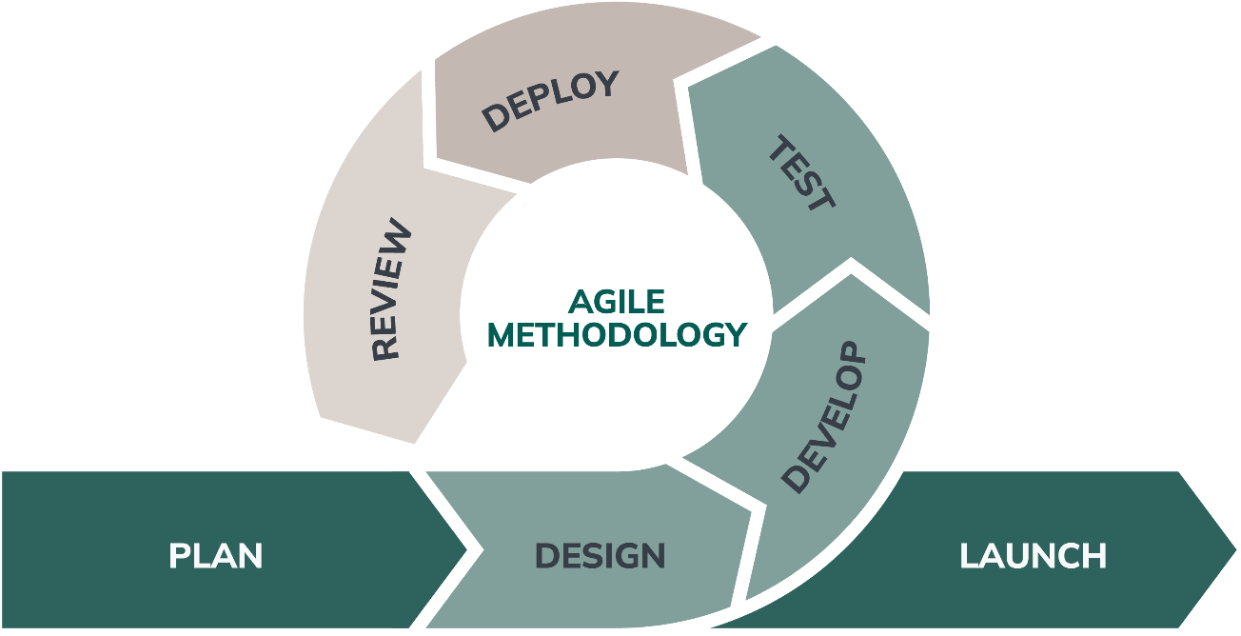
The researchers employed an agile methodology throughout the design process. This approach enabled flexibility and adaptability in iterative design and fostered close collaboration with the client to ensure continuous feedback. By doing so, the research aimed to ensure that the design aligns with the evolving needs and requirements of the University of Eastern Philippines. Here are different phases that serve as instructions to follow during the system design process.

Source: https://www.nexapp.ca/en/blog/agile-software-development
Figure 1. Agile Development Model
Phase | Description
Planning | During this phase, the researchers conducted initial meetings with UEP stakeholders to gather the system's requirements. The discussions focused on identifying the challenges faced in managing research projects, including inefficient proposal processing, lack of centralized documentation, and delays in report tracking. Goals were defined to streamline workflows, ensure transparency, and centralize data for easier monitoring and reporting.
Design | This phase involved creating detailed design plans for the system. The ARPMS architecture was outlined, including user access levels (e.g., Researchers, Supervisors, Admin), UI/UX layouts for dashboards, and the flow of research project data. The system was designed to support modularity—each core function (e.g., proposal submission, progress update, document upload) was modeled independently for ease of iteration and integration. Wireframes and mockups were reviewed and refined with user input.
Development | System design was carried out in sprints, with each sprint focusing on specific features. The design covered user authentication, role-based dashboards, research proposal modules, approval routing, milestone tracking, digital document repository, funding record modules, and automated report generation. The Agile model allowed regular sprint reviews with users to verify if system behavior matched their workflows and expectations.
Testing | Design validation was conducted in stages, including unit testing for individual features (e.g., uploading proposals, submitting progress reports) and integration testing to ensure that modules work seamlessly together. Usability testing sessions were held with selected researchers and faculty members to validate the system's effectiveness in real-use scenarios. Design issues were logged and resolved iteratively.
Deployment | A working prototype design was deployed in a controlled environment within the UEP research office. This version included fully functional design modules such as proposal review, progress tracking, and report generation. The deployment allowed researchers to simulate end-to-end workflows and provide real-time feedback based on actual research activity.
Review | Feedback gathered from deployment testing was used to evaluate system usability, accessibility, and performance. Stakeholders highlighted the need for additional filters in the dashboard and improved notification mechanisms. These observations were analyzed and used to refine the final design version. The review phase ensured the system design addressed real administrative challenges and was aligned with the institution's vision.
Launch | After the final refinements, the fully designed ARPMS was ready for launch across departments. User manuals, training sessions, and documentation were prepared to support onboarding. The system design is now ready to manage research projects more efficiently by offering an integrated platform for proposal submission, monitoring, and reporting—empowering both students and faculty in research engagement and accountability.

Table 2. Phases of the Development Process of the Proposed System
Phases | Description
Requirement Analysis | This involved conducting interviews and engaging in collaborative discussions with the university administrators, researchers, and supervisors to gather vital information about their research management operations and requirements. The focus is on understanding the client's needs and capturing them as user stories or product backlog items. This phase encouraged frequent interactions and feedback between the design team and the stakeholders, allowing for adjustments and refinements as the project progresses.
Design | The design phase centered on creating a comprehensive plan and blueprint for the proposed system. The focus is on designing the system's structure, architecture, and user interface while ensuring alignment with the identified requirements. Agile design emphasizes iterative and incremental design, allowing for continuous feedback and adaptation. Design activities were conducted collaboratively, with the involvement of the design team and stakeholders throughout the process.
Development and Coding | In this phase, the researchers focused on creating the planned system design specifications. The design process involved translating the requirements into functional system components using C# for backend architecture and web technologies for the frontend interface design.
Integration and Testing | In this phase, the researchers focused on integrating the individual system components and thoroughly testing the integrated design. The integration and testing phase aimed to ensure the stability, reliability, and quality of the research management system design before its potential deployment or release.
Implementation and Deployment | The implementation and deployment phase involved preparing the system design solution for operational use by researchers, supervisors, and administrators at UEP. The focus is on quickly delivering working design prototypes to end-users. Agile deployment practices prioritize frequent releases or design iterations, allowing for continuous delivery and feedback.
Review | This involved evaluating the designed system solution and gathering feedback from end-users and stakeholders, including researchers, supervisors, and university administrators. Agile teams regularly review and reflect on design increments to identify areas for improvement and gather insights for future iterations. The review phase promotes continuous learning, adaptation, and refinement of the system design, ensuring that it evolves to meet the changing needs and expectations of the research community at UEP.

Requirements Specifications
Use Case Diagram
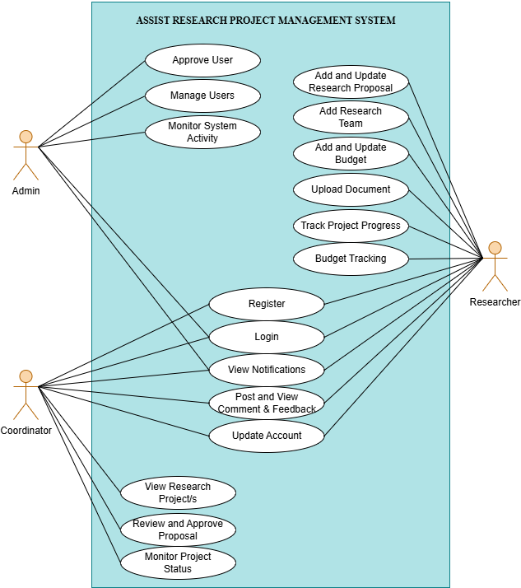

Figure 2: Use Case Diagram of Assist Research Project Management System
The use case diagram defines the interactions among the three core user roles within the system: Admin, Coordinator, and Researcher. The admin oversees system-wide configuration and maintenance, including user approval workflows, account administration, and continuous monitoring of system activities. The coordinator is responsible for managing research operations, which include evaluating and approving research proposals, supervising project progress, accessing research records, issuing feedback, and updating their account settings. The researcher serves as the primary system operator, executing key project-related functions such as user registration and authentication, proposal creation and revision, research team management, document uploading, ongoing progress monitoring, and communication through feedback mechanisms. Additionally, the Researcher is responsible for budget tracking, including inputting, updating, and tracking financial allocations throughout the project lifecycle. Together, these roles interact to facilitate a structured, efficient, and fully monitored research project management workflow.

Compatibility Checking
The assist research project management system design prioritized compatibility to ensure seamless functionality across platforms and devices, including cross-browser support for Google Chrome, Edge, Firefox, and Safari, responsive design for different screen sizes and resolutions, and compatibility with Windows, Mac OS, Linux, Android, and iOS. The system design seamlessly integrated Microsoft SQL Server for efficient data management. This approach aimed to provide a versatile and user-friendly experience for all users. The following tables list the software and hardware requirements needed for design development and for system users:
Table 3. Development Software Requirements
Software | Minimum | Recommended
Operating System | Windows 10 | Windows 11
Web Browser | Latest version | Latest version
Visual Studio | Visual Studio 2019 | Visual Studio 2022 or latest
MSQL Server | SQL Server 2019 | SQL Server 2022
IIS | IIS 10.0 | IIS 10.0 or latest

The implementation of the Assist Research Project Management System relies on a carefully selected set of software requirements that collectively ensure compatibility, scalability, and performance in managing complex research workflows. Windows 11 is recommended as the operating system due to its enhanced security and modern features, while the latest web browsers guarantee seamless access to the system’s web-based interface and compliance with current web standards.
Visual Studio 2022 or newer versions serve as the integrated development environment, providing advanced tools for coding, debugging, and maintaining the system, thereby improving developer productivity and adaptability. SQL Server 2022 functions as the database management system, offering reliable storage, optimized query performance, and scalability for handling extensive research data and project records.
Together, these technologies establish a secure foundation that supports the Assist Research Project Management System in achieving its objectives of accessibility, maintainability, and efficiency across diverse platforms and devices.
Table 4. Deployment Software Requirements
Software | Minimum | Recommended
Operating System | Windows Server 2016 | Windows Server 2022
Web Browser | Latest version | Latest version
Microsoft SQL Server | SQL Server 2019 | SQL Server 2022
IIS | IIS 10.0 | IIS 10.0 or latest

The deployment software requirements are designed to provide a secure and efficient environment for hosting and delivering the Assist Research Project Management System to end users. Windows Server 2016 serves as the minimum operating system for deployment, offering stability and compatibility, while Windows Server 2022 is recommended for its advanced security features, scalability, and support for modern applications.
A web browser in its latest version is essential for accessing the deployed system, ensuring responsiveness and compliance with current web technologies. Microsoft SQL Server 2019 provides reliable database management capabilities, but SQL Server 2022 is preferred for its enhanced performance, scalability, and integration with cloud services.
Together, these deployment requirements guarantee that the Assist Research Project Management System operates securely, efficiently, and reliably in a production environment.

Table 5. Deployment and Development of Hardware Specification
Hardware | Minimum | Recommended
CPU | Intel Core i5 or AMD Ryzen 5 | Intel Core i7 or AMD Ryzen 7 or higher
RAM | 8 GB | 16 GB or more
Storage | 256 GB SSD or higher | 512 GB SSD or higher
Display Resolution | 1366 x 768 or higher | 1920 x 1080 or higher
Operating System | Windows 10 | Windows 11
Network Connection | Broadband Internet Connection | Broadband Internet Connection

The hardware specifications for both development and deployment of the Assist Research Project Management System define the baseline and recommended configurations to ensure reliable performance, responsiveness, and scalability. at minimum, systems should be equipped with an Intel Core i5 or AMD Ryzen 5 processor, 8 GB of RAM, a 256 GB SSD, a display resolution of 1366 × 768 or higher, Windows 10, and a stable broadband internet connection to support collaboration and remote access; for optimal performance—particularly when handling large datasets, concurrent users, and intensive development tasks. Windows 11 is recommended, as these enhancements reduce build and query times, improve multitasking and virtualization capabilities during development, and provide faster data access and smoother user experiences in production deployments.

Relevance of the Technologies
To improve research proposal management, progress tracking, and collaborative research activities, the project for the Assist Research Project Management System aimed to design a comprehensive solution. This solution modernized and simplified these crucial aspects of research operations at the University of Eastern Philippines. By utilizing web-based technology and effective data management design, the system aimed to enhance the proposal submission process for researchers, streamline approval workflows, and offer robust project tracking and collaboration tools. This comprehensive approach was intended to enhance overall research efficiency and promote greater transparency and organization within the university's research activities. Despite the absence of advanced technologies, the designed system effectively fulfilled the requirements of research management operations, improving efficiency and contributing to the overall effectiveness of the academic research process.
Requirements Modeling
Requirements modeling is an essential part of the software development process, where the system requirements were analyzed, documented, and represented in a structured and organized manner.

Table 6
Input, Process, and Output Model
Type | Role | Requirements
Input | Researcher | - research proposal details to submit  - progress report information to upload  - project milestone updates  - collaboration messages and documents  - research document files to store
 | Coordinator | - proposal evaluation and feedback  - approval or revision requests  - progress assessment comments  - resource allocation decisions  - project timeline adjustments
 | Admin | - user account details to register  - system configuration settings  - resource allocation data  - institutional policy updates  - report generation parameters
Process | Researcher | - submit research proposals  - upload progress reports  - update project milestones  - communicate with supervisors  - access project documents  - track project status
 | Coordinator | - review submitted proposals  - approve or request revisions  - monitor research progress  - provide feedback and guidance  - allocate resources to projects  - generate progress reports
 | Admin | - manage user accounts  - configure system settings  - allocate institutional resources  - generate institutional reports  - monitor system usage  - enforce research policies
Output | Researcher | - proposal submission confirmations  - progress tracking dashboards  - collaboration notifications  - project status reports  - document version histories
 | Coordinator | - proposal review summaries  - progress monitoring reports  - resource utilization reports  - project timeline overviews  - performance analytics
 | Admin | - institutional research reports  - resource allocation summaries  - system usage statistics  - compliance monitoring reports  - strategic planning data

Process Modeling
Process modeling plays a crucial role in streamlining research management operations and achieving process automation through effective design. According to Claire Vanner's blog post titled "What is Process Modeling? 6 Essential Questions Answered," process modeling refers to the graphical representation of business operations or workflows. Vanner emphasized the significance of process modeling, highlighting that it serves as a vital component in the automation journey. Before automating a research management process, it is essential to create a process model, as it allows for the definition of tasks and optimization of the workflow through proper design.

Context Diagram
The context diagram is a high-level representation that provides a clear and simplified overview of the system's boundaries, helping stakeholders understand the scope and key data exchanges briefly. It is often used in the early stages of system design and analysis to define how the system fits into a larger environment.

Current System
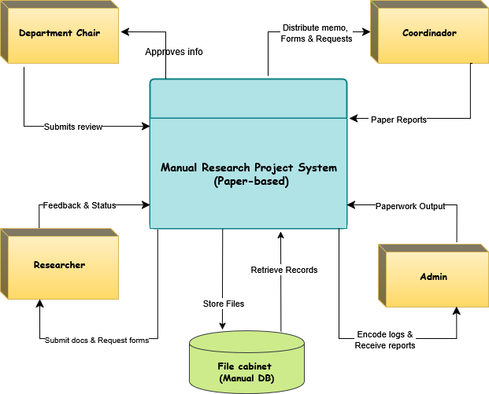
Figure 3. Context Data Flow Diagram for Current System
The current system illustrates how research projects are managed using a fully manual process, a paper-based research project system where all processes rely on physical documents. Researchers submit forms and documents, which are stored in a file cabinet. The coordinator distributes memos and submits paper reports, while the Department Chair manually reviews and approves information. The admin encodes logs and retrieves records from the cabinet. All tasks, from submission to approval, are done without automation, making the system slow and prone to inefficiencies.

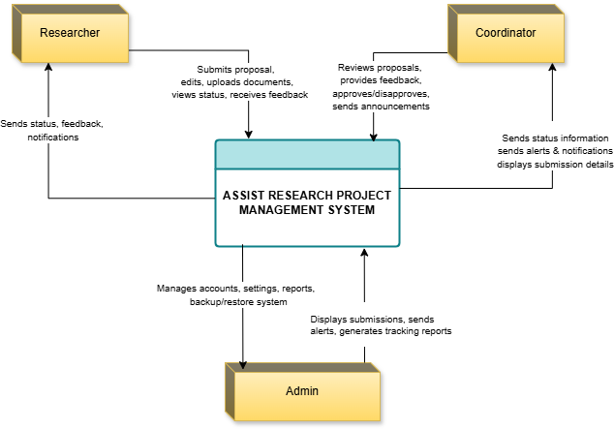
Proposed System

Figure 4. Context Data Flow Diagram for Proposed System
Figure 4 illustrates the flow of the proposed Assist Research Project Management System, building upon the limitations of the current manual process. In the proposed system, the researcher initiates project activities by submitting proposals, uploading documents, adding research team members and budget details, editing entries, and tracking project progress, while the system provides them with status updates, feedback, and notifications to support real-time monitoring and collaboration. The coordinator supervises project submissions by reviewing, approving, or disapproving proposals, and adding comments, as well as sending announcements and receiving alerts, submission details, and notifications from the system to ensure proper oversight and communication. The admin plays a central role in managing the platform by approving new users, updating user statuses, configuring system settings, generating reports, and handling backup and restore functions, with the system displaying submissions, sending alerts, and tracking activity to maintain operational integrity. By automating the flow of data and tasks, the proposed system reduces manual intervention, enhances transparency, and improves efficiency. Following Gane and Sarson's notation, the diagram clearly depicts the movement of data, user interactions, and system processes, making it easier to understand how information is processed, stored, and exchanged within the platform.
Functional Decomposition Diagram
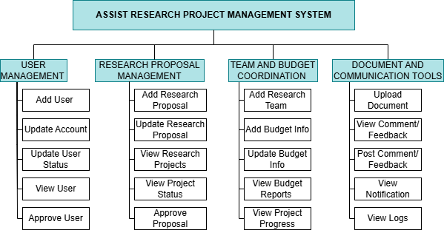

Figure 5: Functional Decomposition Diagram

Figure 5 presents the functional decomposition of the Assist Research Project Management System, breaking down its operations into four main functional domains: User Management, Research Proposal Handling, Team and Budget Coordination, and Document and Communication Tools. Each domain contains essential sub-functions that collectively support the full research project lifecycle.
The User Management function enables administrators to manage user-related activities such as adding new users, updating account information and user status, viewing user profiles, and approving user registrations. These capabilities ensure that user access and roles are properly controlled and maintained throughout the system. The Research Proposal Management function supports the submission, evaluation, and tracking of research proposals. Users can add new proposals, update existing ones, view research projects and their current status, and approve proposals for implementation. This function streamlines the proposal workflow and ensures that research initiatives are properly documented and reviewed. The Team and Budget Coordination function facilitates the organization of research teams and the management of financial resources. It allows users to add team members, input and update budget information, view budget reports, and monitor project progress. These features help align team efforts with financial planning and ensure that projects stay on track both operationally and fiscally.
The Document and Communication Tools function enhances collaboration and transparency within the system. Users can upload documents, view and post comments or feedback, receive notifications, and access system logs. These tools support effective communication among stakeholders and provide a reliable record of project activities.
Overall, this functional decomposition provides a structured framework for managing research projects efficiently, ensuring that all critical tasks are clearly defined and integrated within the system.

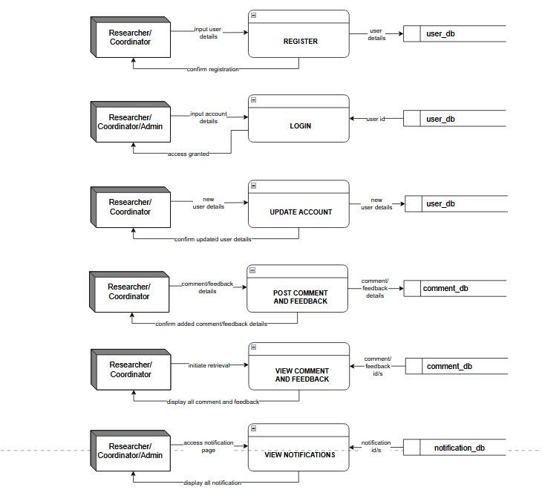
Event Diagram
Figure 6. Register Event Process

The event diagram illustrates what process begins to provide their registration details to the system. These input details are processed and stored in the user_db. Once the registration is successful, the system confirms the registration and notifies the user, completing the account creation process.
Figure 7. Login Event Process

This function illustrates that the users provide their login credentials (account details), which are verified against the user_db. If the credentials are valid, the system grants access and confirms successful login.
Figure 8. Update Account Event Process
In this process illustrates the updated user details are sent to the user_db for storage. After the system successfully updates the record, it sends confirmation to the user that the update has been completed.

Figure 9. Post Comment and Feedback Event Process

This function allows users input their comment or feedback details, which are then stored in the comment_db. The system confirms the successful submission of the comment or feedback to the user.
Figure 10. View Comment and Feedback Event Process

This process illustrates the system receives a request to retrieve data, queries the comment_db using comment or feedback identifiers, and then displays the relevant information to the user.
Figure 11. View Notifications Event Process
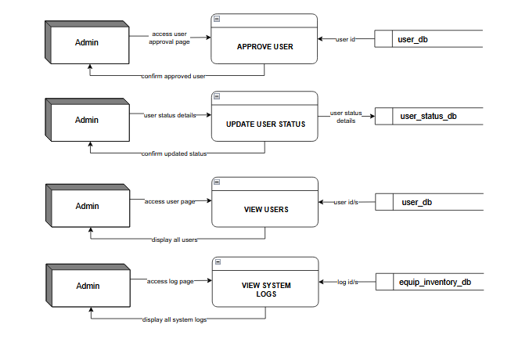
In this final process illustrates the system accesses the notification_db to retrieve all notifications relevant to the user. These notifications are then displayed on the user’s notification page.
Figure 12. Approve User Event Process

This function that allowed admin accesses the user approval page to approve a newly registered user. The system retrieves the user’s information from the user_db using the user ID and confirms the approval action back to the admin.
Figure 13. Update User Status Event Process

This function illustrates that the admin provides updated user status details through the system interface. These status changes are saved into the user_status_db, and the system confirms the update to the admin.
Figure 14. View Users Event Process

This function illustrates the admin opens the user viewing page to see all registered users. The system fetches user information from the user_db using their IDs and displays the list of users to the admin.

Figure 15. View System Logs Event Process
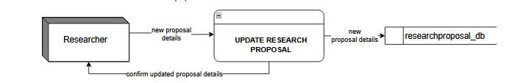
This function illustrates the admin accesses the system logs page to review system activity or equipment history. The system retrieves log data from the equip_inventory_db using log IDs and displays the logs to the admin.

Figure 16. Add Research Proposal Event Process
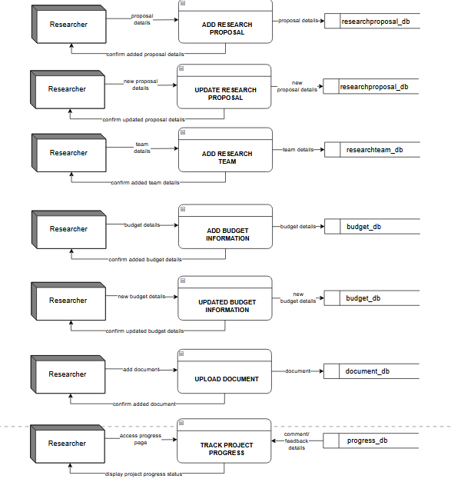
This function illustrates that the researcher submits new proposal details through the system. These details are stored in the researchproposal_db, and the system confirms that the proposal was successfully added.
Figure 17. Add Research Team Event Process

This function illustrates the researcher inputs team member details for a project. These team details are saved in the researchteam_db, and the system confirms successful team registration.
Figure 18. Add Budget Information Event Diagram
This function illustrates that the researcher provides initial budget details for a project. This information is stored in the budget_db, and a confirmation is sent back indicating that the budget has been added.

Figure 19. Updated Budget Information Event Process

This function illustrates when changes to the budget are needed; the researcher enters new budget details. These updates are saved in the budget_db, and the system confirms the changes were successfully recorded.
Figure 20. Upload Document Event Process
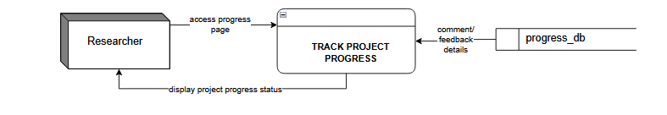
This function illustrates that the researcher uploads supporting documents for the project. These files are stored in the document_db, and the system confirms that the upload was successful.
Figure 21. Track Project Progress Event Process
This function illustrates that the researcher accesses the progress page to monitor or update the project's progress. The
system retrieves and displays the current status from the progress_db, possibly including comments or feedback.
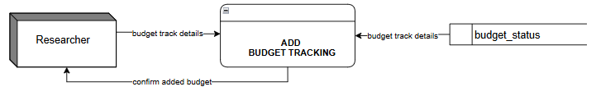
Figure 22. Add budget Tracking Event Diagram
This function illustrates that the researcher accesses the budget tracking page to monitor or update the project’s budget. The system retrieves and displays the current budget details from the budget_status database and confirms any updates made, ensuring accurate tracking and proper financial monitoring.
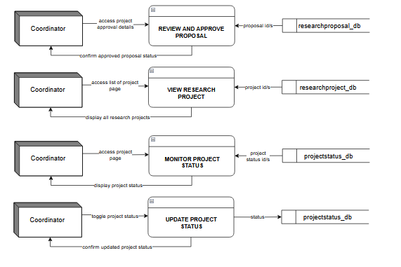

Figure 23. Review and Approve Proposal Event Process

This function illustrates the system retrieves proposal information from the researchproposal_db using proposal IDs. Once reviewed, the system updates the proposal’s approval status and confirms it to the coordinator.
Figure 24. View Research Project Event Process

This function illustrates the coordinator accesses the list of research projects. The system fetches the project data from the researchproject_db using project IDs and displays all available research projects to the coordinator for review or reference.

Figure 25. Monitor Project Status Event Process

This function illustrates to oversee project development; the coordinator accesses the project status monitoring page. The system retrieves current status updates from the projectstatus_db and displays them, allowing the coordinator to track ongoing progress.
Figure 26. Update Project Status Event Process
This function illustrates that if any changes are required, the coordinator toggles or modifies the status of a project. The system updates the status in the projectstatus_db and confirms
The changes to the coordinator ensuring the project status stays up-to-date.

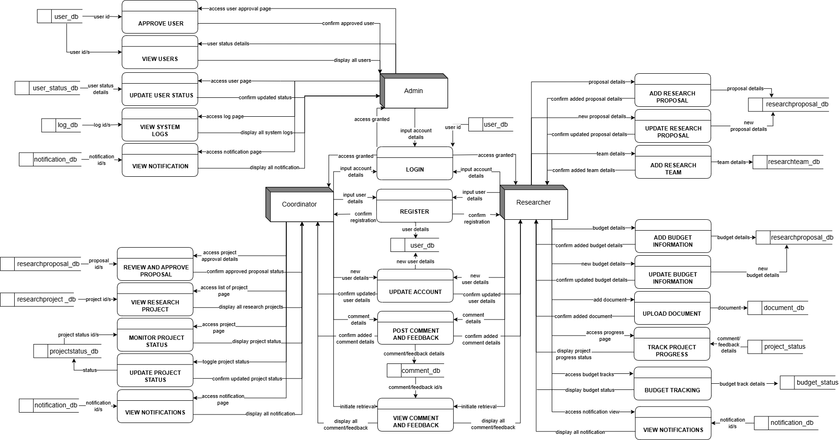
System Diagram

Figure 27: System Diagram

Figure 27 presents the System Diagram of the Assist Research Project Management System, which illustrates the complete flow of data between users, processes, and data stores using the Gane and Sarson notation. The system involves three main actors—Admin, Coordinator, and Researcher—each with distinct responsibilities and access to different modules. The admin manages user accounts, approves users, updates statuses, views system logs, and handles notifications. The coordinator oversees research proposals by reviewing and approving them, monitors and updates project statuses, views research projects, and accesses system notifications. The researcher, as the main contributor of research content, can add and update research proposals, form research teams, manage and track budget information, upload documents, track project progress, and view notifications. Common processes such as Login, Register, Update Account, and Post/View Comments and Feedback are accessible by all users and connect directly to shared data stores like user_db and comment_db.
Each function is supported by corresponding data stores (e.g., researchproposal_db, budget_db, projectstatus_db) that ensure secure and structured data management throughout the Assist Research Project Management System.

Data Modeling

The data model for the Assist Research Project Management System outlines the key entities and their relationships to manage research activities efficiently. The central entity is User, connected to CollegeDepartment, Logs, Notifications, and Comments to track user roles, actions, and interactions. ResearchProposal is a core entity created by users and linked to ResearchTeam, Documents, Milestones, and ProjectStatus—providing a structured flow from proposal to project. Once approved, proposals become ResearchProjects. This model supports collaboration, monitoring, and documentation throughout the research lifecycle.

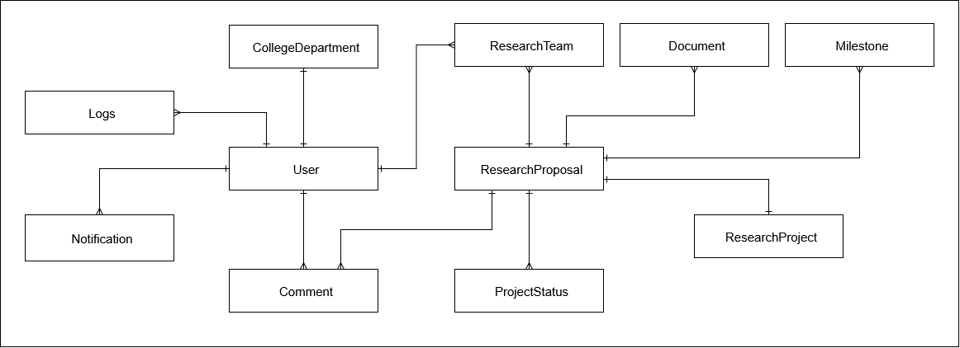Figure 28: Context Data Model for Assist Research Project Management System

Key-based Data Model
The key-based data model for the Assist Research Project Management System uses primary and foreign keys to ensure accurate and consistent relationships between entities. The central entity is ResearchProposal, linked to users (submitter and reviewer), teams, documents, milestones, and project status using the proposal_id as a common foreign key. The User entity, identified by user_id, is connected to logs, notifications, comments, and departments. These key relationships maintain data integrity and support efficient tracking of user actions, proposal progress, and project development throughout the system.
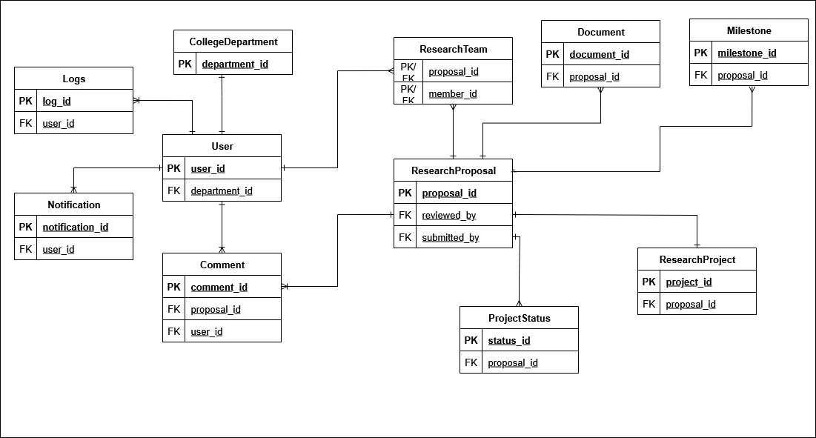

Figure 29: Key-based Data Model for Assist Research Project Management System

Fully Attributed Data Model
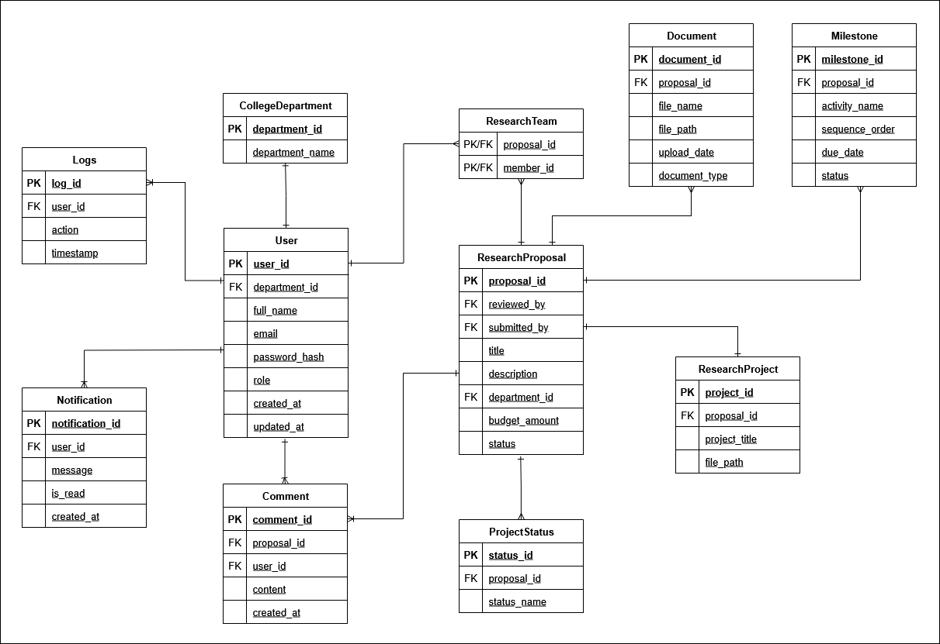
The fully attributed data model for the Assist Research Project Management System provides a complete structure of all entities and their attributes, supporting detailed data management. Key entities include User, with fields like name, email, and role; ResearchProposal, with details such as title, description, budget, and status; and ResearchProject, which holds project titles and file paths. Relationships are maintained using foreign keys across linked entities like CollegeDepartment, ResearchTeam, Document, Milestone, Comment, and ProjectStatus. This model ensures accurate, consistent, and traceable data throughout the research lifecycle.

Figure 30: Fully Attributed Data Model for Assist Research Project Management System
Data Dictionary
Table 7. College department Entity
Field | Type | Description
department_id | PK, INT | Unique identifier for each department.
department_name | VARCHAR | Name of the academic department (e.g., College of Science).

Table 8. User Entity
Field | Type | Description
user_id | PK, INT | Unique user identifier.
department_id | FK, INT | Linked department.
full_name | VARCHAR | User’s full name.
email | VARCHAR | User’s email (used for login).
password_hash | VARCHAR | Encrypted password.
role | VARCHAR | Role in system (e.g., Researcher, Coordinator).
created_at | DATETIME | When the account was created.
updated_at | DATETIME | Last account update.

Table 9. Logs entity
Field | Type | Description
log_id | PK, INT | Unique log entry ID.
user_id | FK, INT | Related user.
action | TEXT | Description of user action.
timestamp | DATETIME | Time of action.

Table 10. Notification Entity
Field | Type | Description
notification_id | PK, INT | Unique notification ID.
user_id | FK, INT | Recipient of the notification.
Message | TEXT | Notification content.
is_read | BOOLEAN | Status of the notification.
created_at | DATETIME | Time sent.

Table 11. Research Proposal Entity
Field | Type | Description
proposal_id | PK, INT | Unique proposal ID.
submitted_by | FK, INT | User who submitted the proposal.
reviewed_by | FK, INT | Assigned reviewer (optional).
title | VARCHAR | Title of the proposal.
description | TEXT | Summary of the research.
department_id | FK, INT | Affiliated department.
budget_amount | DECIMAL | Total proposed budget.
status | VARCHAR | Initial proposal status.

Table 12. Research Team Entity (Junction Table)
Field | Type | Description
proposal_id | PK/FK, INT | Proposal reference.
member_id | PK/FK, INT | Team member reference (User).

Table 13. Document/S Entity
Field | Type | Description
document_id | PK, INT | Unique document record.
proposal_id | FK, INT | Associated proposal.
file_name | VARCHAR | Name of file uploaded.
file_path | VARCHAR | File storage location.
upload_date | DATETIME | Time uploaded.
document_type | VARCHAR | Type (e.g., proposal, supporting doc).

Table 14. Milestone Entity
Field | Type | Description
milestone_id | PK, INT | Unique milestone ID.
proposal_id | FK, INT | Associated proposal.
activity_name | VARCHAR | Activity title (e.g., Literature Review).
sequence_order | INT | Order of activity.
due_date | DATE | Deadline for the activity.
Status | VARCHAR | Status of activity (e.g., Done, Pending).

Table 15. Research Project Entity
Field | Type | Description
project_id | PK, INT | Unique project ID.
proposal_id | FK, INT | Associated proposal.
project_title | VARCHAR | Final title of the research project.
file_path | VARCHAR | Final proposal file.

Table 16. Comment Entity
Field | Type | Description
comment_id | PK, INT | Unique comment ID.
proposal_id | FK, INT | Associated research project.
user_id | FK, INT | Commenting user.
content | TEXT | Text of the comment.
created_at | DATETIME | Time posted.

Table 17. Project Status Entity
Field | Type | Description
status_id | PK, INT | Unique status entry.
proposal_id | FK, INT | Linked project.
status_name | VARCHAR | Status value (e.g., In Progress, On Track, At Risk).

Interface Modeling
Interface modeling utilizes data-driven visual representations to design user interfaces efficiently. These models were crucial for planning and creating intuitive and user-friendly interfaces. In this section, the researchers delved into the significance of interface modeling and its role in crafting compelling user experiences for the research management system design.

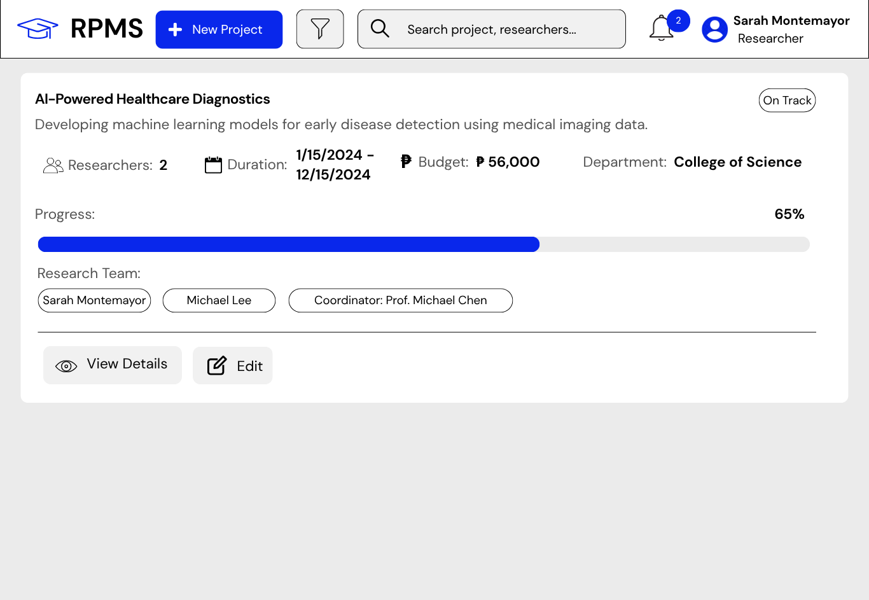
Proposed UI Model

Figure 31: Login Page
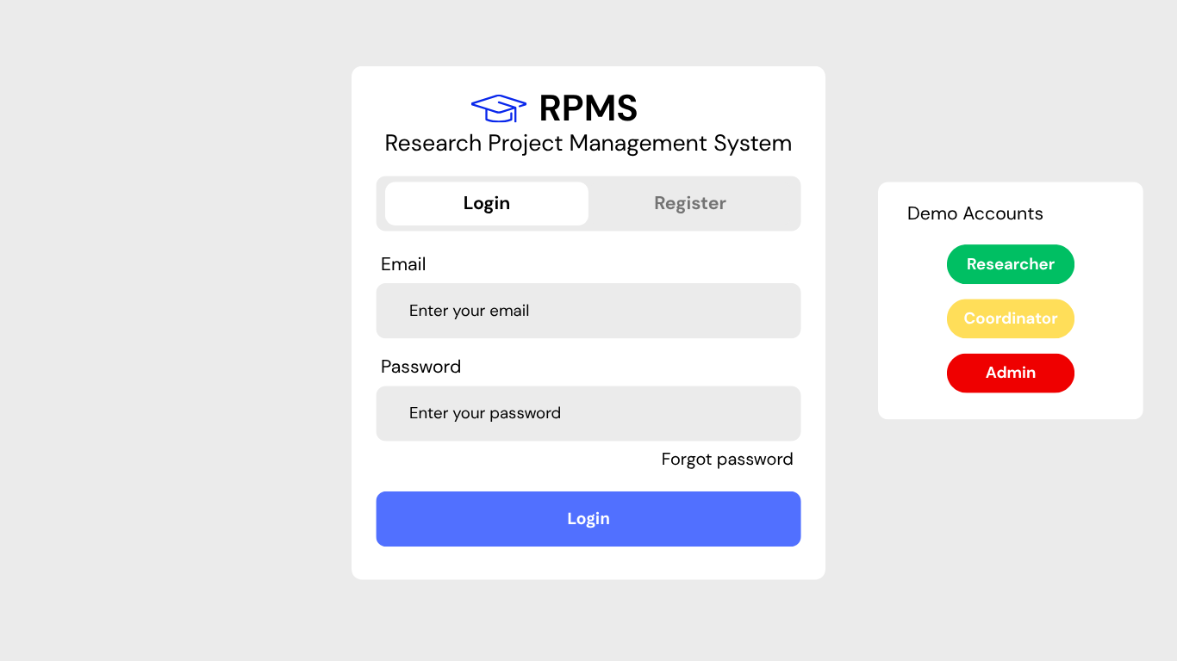

Figure 32: Researcher Dashboard
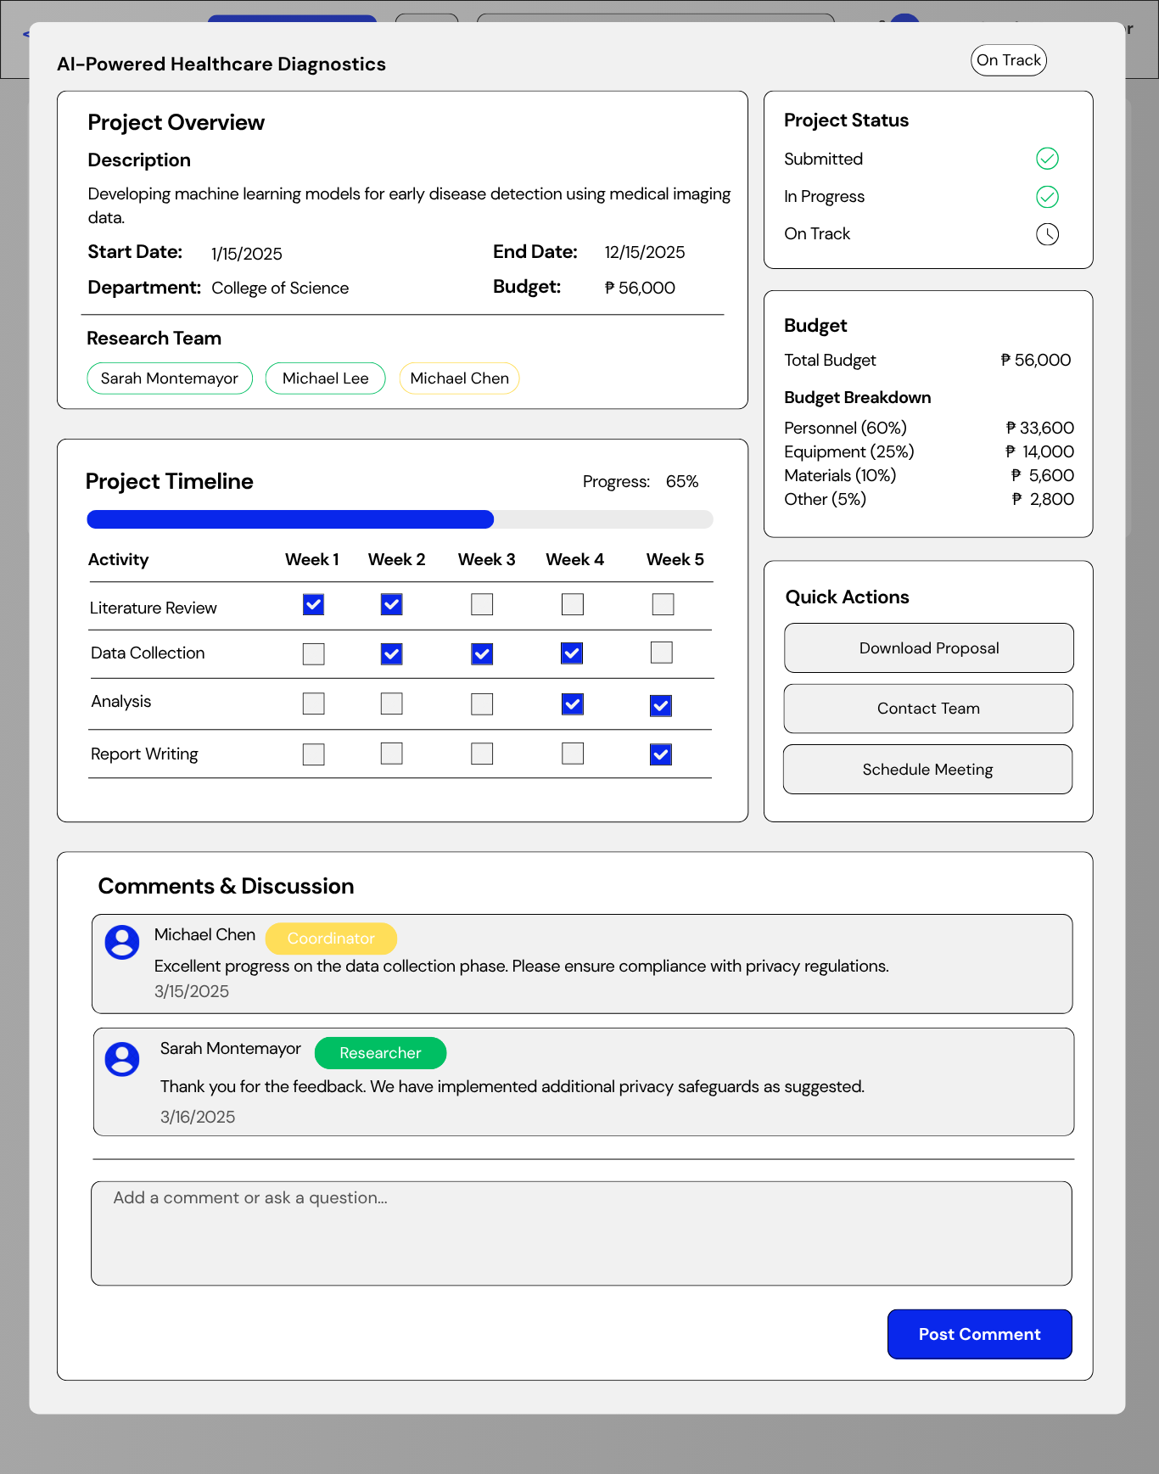
Figure 33: View Project Details
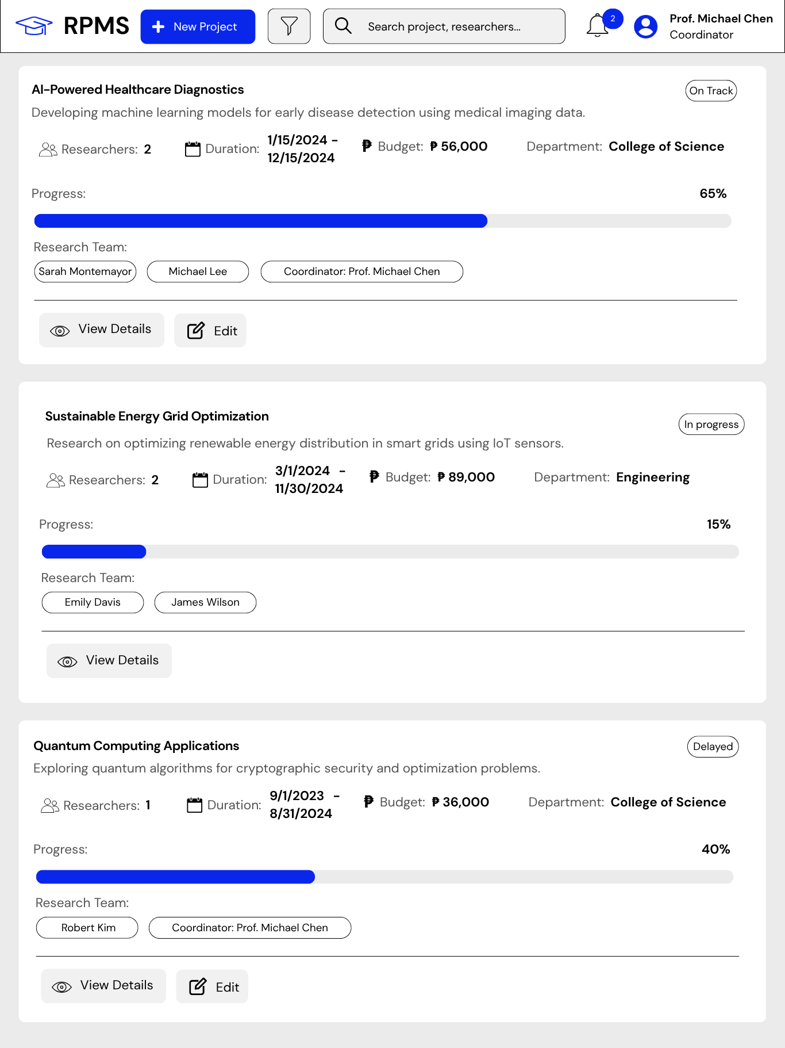
Figure 34: Coordinator Dashboard

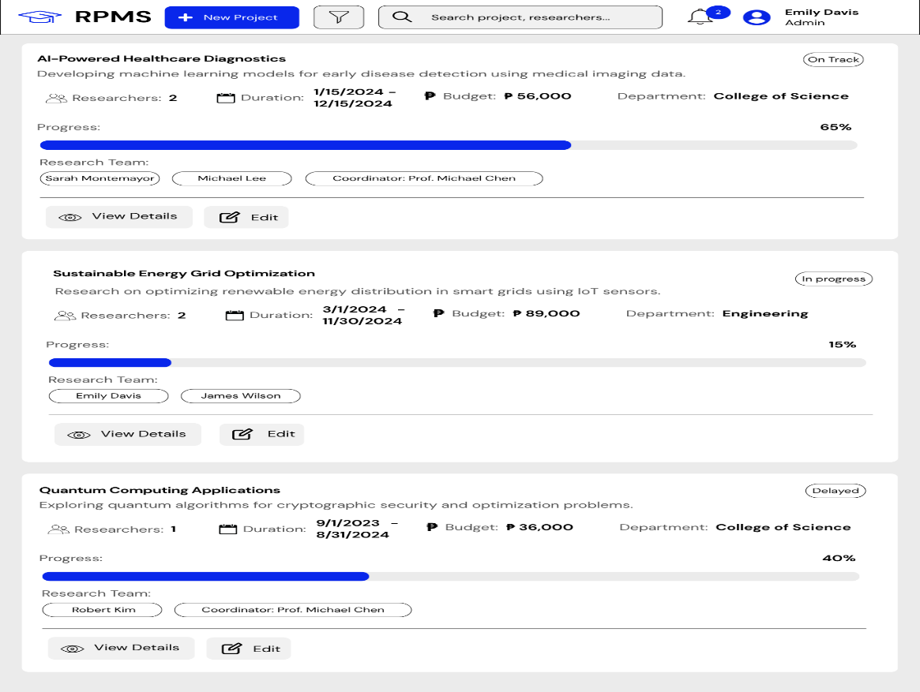
Figure 35: Admin Dashboard

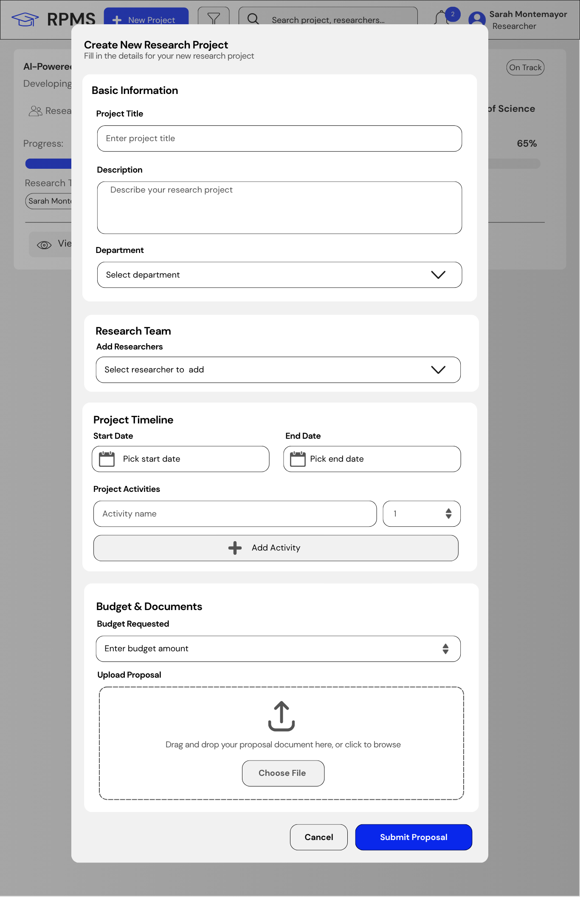
Figure 36: Submit New Project (Researcher Form)

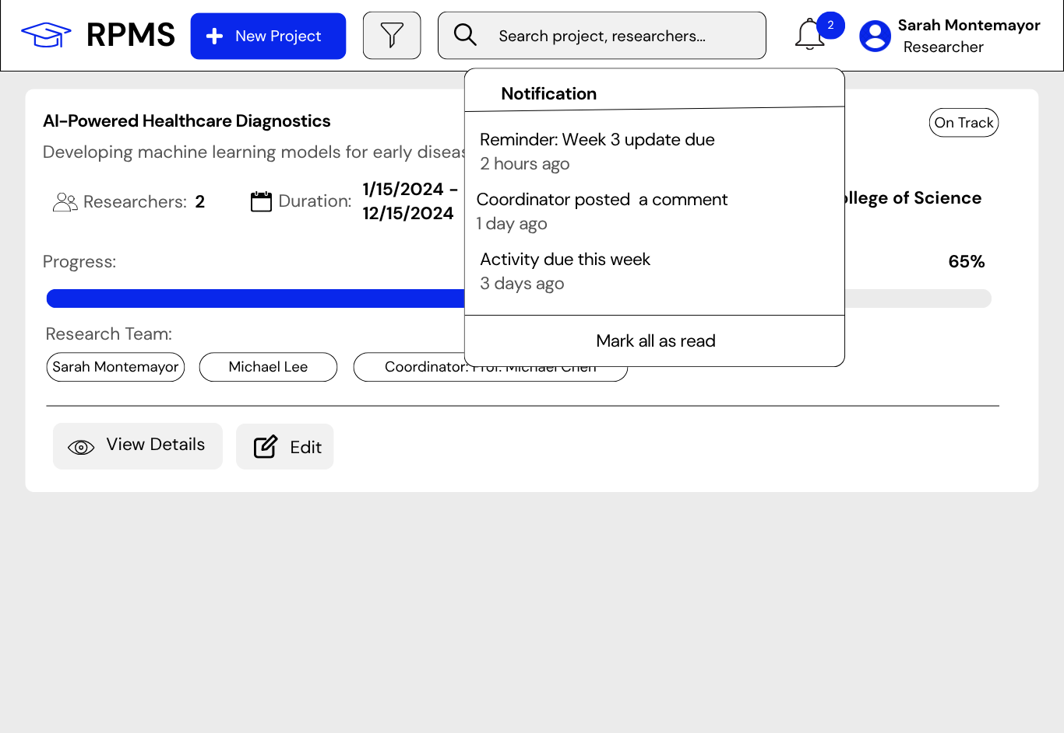
Figure 37: Notification Panel

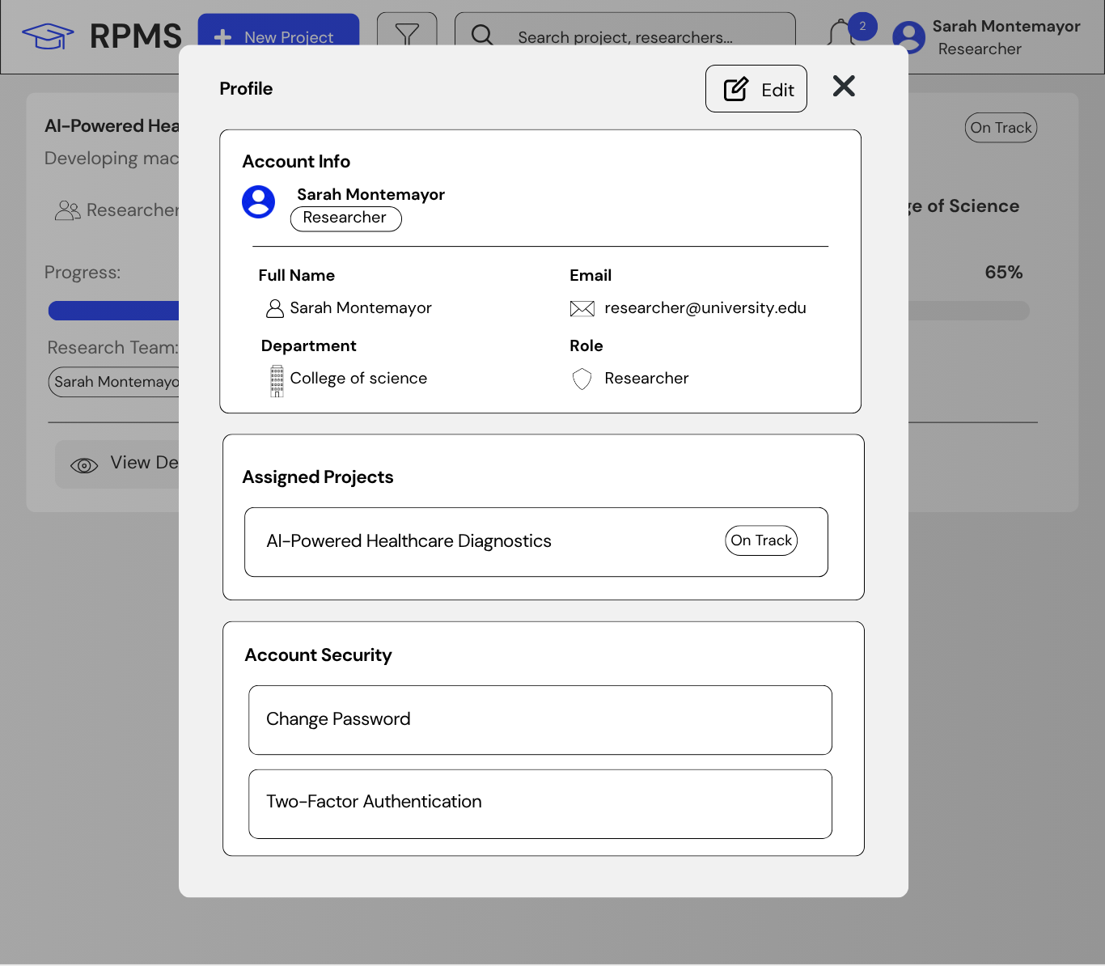
Figure 38: Profile Panel

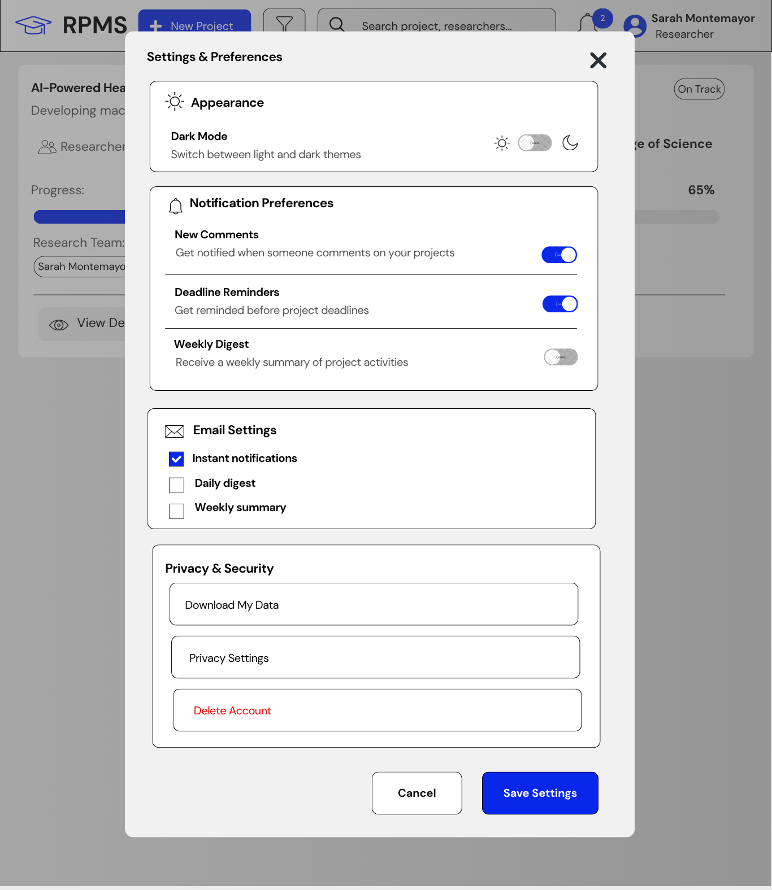
Figure 39: Settings Panel

Chapter IV
SYSTEM IMPLEMENTATION AND UNIT TESTING
Table 18. Software Specification
Software | Minimum | Recommended
Operating System | Windows 10 | Windows 11
Web Browser | Latest version | Latest version
Visual Studio | Visual Studio 2019 | Visual Studio 2022 or latest
MSQL Server | SQL Server 2019 | SQL Server 2022
IIS | IIS 10.0 | IIS 10.0 or latest

The "Assist Research Project Management System" is built using ASP.NET Core MVC, a robust framework known for better performance, cleaner code, and an improved user experience. This choice ensured smooth compatibility with modern browsers and simplifies the creation of an efficient platform for managing research operations. Customized interfaces for different roles, like Researchers, Research Coordinators, Department Heads, and System Administrators, are designed with user-friendly principles for easy navigation, optimizing daily operations, and making the research management process smoother.
To enhance system security, the researchers used JSON Web Token (JWT) for user authentication and access control. This provided a secure way to verify user identities without the need for additional security measures, improving the overall integrity of the system. Additionally, the system included performance optimization features such as server-side caching and asynchronous processing, contributing to a responsive and reliable user experience. The design also focused on scalability, ensuring that the system could handle potential growth in data, users, and functionality, making it ready for increasing demands.
Furthermore, a strong emphasis on usability was maintained throughout the development process, ensuring that the interface remains efficient for daily operations and user-friendly for individuals with different roles. This commitment to user-friendly design principles contributed to a positive experience for everyone involved in the University of Eastern Philippines research community. The strategic use of ASP.NET Core MVC and JWT highlighted the project's dedication in delivering a comprehensive, secure, scalable, and accessible solution that meets the diverse needs of the university's stakeholders.

Table 19. Hardware Specification
Hardware | Minimum | Recommended
CPU | Intel Core i5 or AMD Ryzen 5 | Intel Core i7 or AMD Ryzen 7 or higher
RAM | 8 GB | 16 GB or more
Storage | 256 GB SSD or higher | 512 GB SSD or higher
Display Resolution | 1366 x 768 or higher | 1920 x 1080 or higher
Operating System | Windows 10 | Windows 11
Network Connection | Broadband Internet Connection | Broadband Internet Connection

In the implementation of the "Assist Research Project Management System," careful consideration was given to the hardware specifications, ensuring optimal performance for the web-based application designed for internal communication within the organization. The chosen hardware was aligned with the demands of managing various account roles efficiently.
Picking an AMD Ryzen 3 processor and 8 GB RAM as recommended hardware specifications matched the lightweight nature of the application, ensuring quick data processing and the ability to handle multiple tasks at once. The 512 GB SSD was chosen to offer plenty of storage space for managing data related to research proposals, progress tracking, and documentation tasks, contributing to efficient system performance. The choice of 8 GB RAM struck a balance between meeting performance needs and using resources effectively, fitting the current requirements of the web-based system. This selection acknowledged that the application's features did not demand excessive resources, maintaining a good user experience within the specified hardware limits.
Furthermore, a stable and reliable internet connection was a crucial component, facilitating real-time transactions and seamless communication among the diverse roles involved. These hardware specifications underscored the project's commitment to delivering a reliable, scalable, and efficient solution for the dynamic operations of the University of Eastern Philippines research management, specifically tailored with the internal communication requirements within the organization.

Program Specification
The program specification for the "Assist Research Project Management System" focused on streamlining the research management operations within the university, adhering to the existing processes of submitting, reviewing, and monitoring research projects. The system catered to various users, each assigned specific role was aligned with the defined research management process of the University of Eastern Philippines:
a. System Administrator
- Manages user accounts for researchers and coordinators, including registration, updates, and control of operational abilities.
- Monitors system logs and maintains overall system health.
b. Research Coordinator
- Manages research oversight, including proposal review, project monitoring, and progress evaluation.
- Handles the approval and supervision of research projects and milestones.
c. Department Head
- Oversees departmental research activities and resource allocation.
- Reviews and approves research proposals from the department level.
d. Researcher
- Manages research proposal submission, team formation, and document uploads.
- Records and manages project progress, milestones, and budget tracking.
These roles have mirrored the current research management process at the University of Eastern Philippines, ensuring a seamless transition to a digitalized and advanced operation. The system incorporated key features aimed at enhancing efficiency, including streamlined proposal submission, review processes, and transparent project monitoring.
Moreover, the capstone project incorporated various features aimed at optimizing research management operations and enhancing user experiences. These features were strategically designed to align with the roles and responsibilities of different users within the university:
- User Management
The System Administrator can manage user accounts, facilitate the registration, update and control operational access for various researchers and coordinators. This centralized user management ensures organized and secure access to the system.
b. Digital Repository Management
The system oversees the storage and organization of research documents, proposals, and supporting files, providing a comprehensive view of the university's research documentation. This feature streamlines the management of research materials within the institution.
- Proposal Submission and Review
Researchers handle the submission of proposals and the monitoring of review status. This feature ensures an organized and efficient process for submitting research proposals within the university.
d. Project Monitoring and Tracking
The coordinator plays a key role in monitoring various research aspects, including the progress of proposals, milestone completion, and budget utilization. This feature provides a centralized platform for research oversight, promoting accuracy and transparency.
e. Collaboration and Communication Tools
Users responsible for research collaboration, including Researchers and Coordinators, contribute to the systematic communication and efficient management of feedback and comments within the system.
f. Report Generation
Coordinators and Administrators have the ability to generate reports, such as project status reports, budget summaries, and progress updates. This reporting feature enhances decision-making processes by offering insights into the university's research operations and overall productivity.
These features collectively contributed to the efficiency, transparency, and organization of the research management process within the University of Eastern Philippines. The system's comprehensive functionality ensures that each user can perform their designated tasks seamlessly while providing the necessary tools for managerial oversight and reporting.

Programming Environment
Front End
In front-end development, responsible for the user interface and experience, modern technologies are employed to ensure an intuitive and visually appealing interaction for users. The system's user interfaces were crafted using HTML, CSS, and JavaScript, with ASP.NET Core MVC Razor views providing dynamic content rendering. This choice was driven by ASP.NET Core's emphasis on improved performance, cleaner code, and a smoother user experience. Leveraging the latest features of ASP.NET Core MVC, the front-end development aimed to provide a seamless and responsive platform accessible across various devices and browsers.

Back End
The back end of the system, dealing with server-side logic, data management, and overall system functionality, is developed using a robust technology stack. The programming environment for the back end relies on C# with ASP.NET Core MVC, known for its efficiency and scalability in handling concurrent connections. The choice of ASP.NET Core was aligned with the system's web-based nature, ensuring swift and efficient communication between the server and client. The back-end logic was seamlessly integrated with a MySQL database, facilitating organized data storage, retrieval, and management.
ASP.NET Core MVC brought a significant shift by seamlessly combining front-end and back-end development, allowing the creation of cohesive full-stack web applications. Its integrated approach simplified the development process, fostering efficiency and reducing complexities. This ensured that the chosen technologies contribute seamlessly to the project's goals, providing an optimized and comprehensive solution for efficient research management operations.

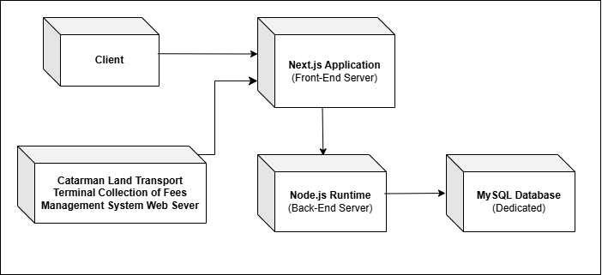
Deployment Diagram

Figure 26. Deployment Diagram
The diagram illustrates the deployment structure for the efficient operation of the research management system at the University of Eastern Philippines. It encompasses a Front-End Server, a Back-End Server, and a dedicated MySQL Database Server. Users interact with the system through various client devices, creating a streamlined flow of requests and data processing between the servers and the database.

Implementation Plan
The implementation plan for the research management system at University of Eastern Philippines complied with the agile development methodology, emphasizing iterative progress and continuous stakeholder involvement. Initially, thorough visits to stakeholders were conducted, engaging in regular discussions to gain a comprehensive understanding of the existing research management process. Clear requirements were collaboratively established to ensure that the system was aligned with the university's specific needs.
The project was divided into sprints, focusing on distinct features. Beginning with the setup of the development environment and integration of ASP.NET Core MVC for full-stack development, subsequent sprints prioritize the integration of back-end logic, database functionality, and overall system integration. Post-front-end and back-end coding and manual unit testing was rigorously practiced during integration and development phases to ascertain individual software components' functionality, accuracy, and efficiency.
Following integration and testing, the system underwent the implementation and deployment phase, where the fully functional system was introduced into the university operation. This stage involves comprehensive training for end-users to ensure a smooth transition and effective utilization of the new system. After successful implementation, a review phase was initiated, including a detailed survey among users to assess the system's acceptability in terms of performance, information availability, efficiency, control and security measures, economic impact, and overall services.

Unit Testing
The management system for research operations at the University of Eastern Philippines was equipped with multiple user interfaces specifically designed to accommodate various roles involved in the research management process. To evaluate its usability, a survey was conducted using the PIECES Framework, which assessed performance, information and data quality, economics, control and security measures, efficiency, and service provision. For the evaluation, the System Usability Scale (SUS) was adapted to fit the specific roles within the client organization—researchers, research coordinators, department heads, and the system administrator. This customization involved introducing factors such as performance, information quality, efficiency, control and security measures, economic impact, and service provision, with participants using a 5-point response system to provide detailed feedback.
Following a survey conducted to assess the performance, control and security measures, efficiency, economics, service provision, and information quality of the Assist Research Project Management System, researchers analyzed the results to gauge the system's acceptability and pinpoint areas requiring improvement. The survey outcomes provide valuable insights into how users perceive the system's operations and offer actionable feedback to improve its functionality and enhance the overall user experience.
Table 20. Verbal Interpretation
Points | Range | Interpretation
5 | 4.21-5.00 | Highly Acceptable -- The web application is highly acceptable to users. It works well and meets all or most of their needs, with very few or no usability issues.
4 | 3.41-4.20 | Acceptable -- It works well and meets most of their needs, but there may still be some room for improvement.
3 | 2.61-3.40 | Moderately Acceptable -- It generally works well, but some usability issues could be improved.
2 | 1.81-2.60 | Slightly Acceptable -- The web application is somewhat acceptable to users, but it has noticeable flaws and usability issues that could be improved.
1 | 1.00-1.80 | Not Acceptable -- It has significant flaws and usability issues that make it difficult or impossible to use effectively.

The weighted mean was computed using the formula:
$$\text{WM}=\frac{\left(5×SA)+(4×A)+(3×N)+(2×D)+(1×SD\right)}{N}$$With a total of 17 respondents, the computed weighted mean is:
$$\text{WM}=\frac{71}{17}=4.18$$
Based on the rating scale, a weighted mean of 4.18 falls within the range 3.41–4.20, which is interpreted as Acceptable, indicating that the web application meets most user requirements with minor areas for improvement.
To enhance result interpretability, a Weighted Mean calculation was applied to each survey statement and an overall weighted mean for each factor was determined. This approach assigned different weights to statements based on their perceived significance within each factor, offering a comprehensive understanding of the system's strengths and weaknesses from the perspective of researchers, coordinators, department heads, and the system administrator. The adapted SUS, along with weighted interpretation, provided detailed insights that quantified perceived usability and highlighted specific improvement areas tailored to the roles of client stakeholders at the University of Eastern Philippines.

Table 21.
A. User Evaluation of the Assist Research Project Management System in terms of Performance
STATEMENT | SA (5) | A (4) | N (3) | D (2) | SD (1) | WM | Interpretation
1. The system responds quickly to user interactions. | 2 | 5 | 2 | 0 | 0 | 4.00 | Acceptable
2. The system efficiently handles simultaneous transactions during busiest hours. | 1 | 6 | 2 | 0 | 0 | 3.89 | Acceptable
3. Overall system speed and responsiveness meet my expectations. | 2 | 5 | 2 | 0 | 0 | 4.00 | Acceptable
4. I experience minimal delays or lags when performing tasks within the system. | 1 | 4 | 4 | 0 | 0 | 3.67 | Acceptable
5. The system's performance contributes positively to my efficiency in research management operations. | 2 | 6 | 1 | 0 | 0 | 4.11 | Acceptable
Total Weighted Mean |  |  |  |  |  | 3.93 | Acceptable

The Assist Research Project Management System generally meets users' expectations in terms of performance, with an overall rating falling within the "Acceptable" range. However, there are some areas where improvements could be made to minimize delays or lags during tasks, as indicated by the acceptable rating for question 4. Overall, the system is functional and contributes positively to users' efficiency in research management operations.

Table 22.
B. User Evaluation of the Assist Research Project Management System in terms of Information
STATEMENT | SA (5) | A (4) | N (3) | D (2) | SD (1) | WM | Interpretation
1. The system provides clear and accurate information regarding research transactions. | 3 | 5 | 1 | 0 | 0 | 4.22 | Highly Acceptable
2. I found the system's user interfaces easy to understand and navigate. | 2 | 6 | 1 | 0 | 0 | 4.11 | Acceptable
3. The information presented in the system is relevant to my role in research management operations. | 3 | 4 | 2 | 0 | 0 | 4.11 | Acceptable
4. The system accurately records and maintains transactions related to research projects. | 3 | 5 | 1 | 0 | 0 | 4.22 | Highly Acceptable
5. The information the system provides enhances my ability to carry out research management tasks efficiently. | 2 | 6 | 1 | 0 | 0 | 4.11 | Acceptable
Total Weighted Mean |  |  |  |  |  | 4.15 | Acceptable

The Assist Research Project Management System performs well in providing clear, accurate, and relevant information to users. The user interfaces are generally easy to understand and navigate, contributing to efficient research management tasks. Additionally, the system accurately records transactions, enhancing users' ability to carry out their roles effectively. Overall, the information aspect of the system is rated as acceptable, with a weighted mean falling within the "Acceptable" range.

Table 23.
C. User Evaluation of Assist Research Project Management System in terms of Efficiency
STATEMENT | SA (5) | A (4) | N (3) | D (2) | SD (1) | WM | Interpretation
1. The system efficiently processes transactions and provides timely responses. | 2 | 6 | 1 | 0 | 0 | 4.11 | Acceptable
2. The system effectively handles simultaneous transactions without a significant decrease in performance. | 1 | 6 | 2 | 0 | 0 | 3.89 | Acceptable
3. I found the system to be responsive and quick in performing various operations. | 1 | 7 | 1 | 0 | 0 | 4.00 | Acceptable
4. The system minimizes delays in recording and processing transactions, ensuring a smooth operation. | 2 | 5 | 2 | 0 | 0 | 4.00 | Acceptable
5. I experience minimal downtime or interruptions while using the system for research management. | 1 | 5 | 3 | 0 | 0 | 3.78 | Acceptable
Total Weighted Mean |  |  |  |  |  | 3.96 | Acceptable

The Assist Research Project Management System demonstrates acceptable efficiency according to user feedback. It efficiently processes transactions, handles simultaneous transactions effectively, and minimizes delays in recording and processing transactions. However, there may be some room for improvement in minimizing downtime or interruptions during system usage, as indicated by the slightly lower rating for question 5. Overall, the system's efficiency is rated as acceptable, with a weighted mean falling within the "Acceptable" range.

Table 24.
D. User Evaluation of Assist Research Project Management System in terms of Control
STATEMENT | SA (5) | A (4) | N (3) | D (2) | SD (1) | WM | Interpretation
1. The system provides sufficient user controls, allowing each role to access only the necessary features and functionalities. | 2 | 6 | 1 | 0 | 0 | 4.11 | Acceptable
2. Users feel confident in the security measures implemented within the system, protecting sensitive data. | 2 | 5 | 2 | 0 | 0 | 4.00 | Acceptable
3. The system ensures data privacy and compliance with security standards relevant to research management. | 2 | 5 | 2 | 0 | 0 | 4.00 | Acceptable
4. Users trust the system's authentication mechanisms, ensuring that only authorized individuals can access sensitive information. | 2 | 5 | 2 | 0 | 0 | 4.00 | Acceptable
5. The system provides a secure environment for research transactions, preventing unauthorized access or tampering. | 2 | 6 | 1 | 0 | 0 | 4.11 | Acceptable
Total Weighted Mean |  |  |  |  |  | 4.04 | Acceptable

The Assist Research Project Management System's control and security measures are generally rated as acceptable by users. The system provides sufficient user controls, implements security measures to protect sensitive data, ensures data privacy and compliance with relevant security standards, and maintains trust in its authentication mechanisms. Additionally, the system provides a secure environment for research transactions. Overall, the control and security aspect of the system is considered acceptable, with a weighted mean falling within the "Acceptable" range.

Table 25.
E. User Evaluation of the Assist Research Project Management System in terms of its Economics
STATEMENT | SA (5) | A (4) | N (3) | D (2) | SD (1) | WM | Interpretation
1. I perceived a positive economic impact on the overall efficiency and cost-effectiveness of research management operations. | 1 | 5 | 3 | 0 | 0 | 3.78 | Acceptable
2. The system contributes to time savings, reducing the operational costs associated with manual research management processes. | 2 | 5 | 2 | 0 | 0 | 4.00 | Acceptable
3. I found the system cost-effective, considering the benefits gained in terms of time, resources, and accuracy. | 1 | 6 | 2 | 0 | 0 | 3.89 | Acceptable
4. The implementation of the system aligns with budget considerations, providing value for the invested resources. | 1 | 6 | 2 | 0 | 0 | 3.89 | Acceptable
5. The introduction of the system positively impacts the research management of the University of Eastern Philippines. | 3 | 5 | 1 | 0 | 0 | 4.22 | Highly Acceptable
Total Weighted Mean |  |  |  |  |  | 3.96 | Acceptable

The Assist Research Project Management System generally demonstrates acceptable economic benefits according to user feedback. Users perceive a positive economic impact on overall efficiency and cost-effectiveness, with contributions to time savings and reductions in operational costs. Additionally, the system is considered cost-effective, aligning with budget considerations and providing value for invested resources. Furthermore, the introduction of the system highly positively impacts the research management of the University of Eastern Philippines. Overall, the economics aspect of the system is rated as acceptable, with a weighted mean falling within the "Acceptable" range.
Table 26.
F. User Evaluation of the Assist Research Project Management System in terms of its Services
STATEMENT | SA (5) | A (4) | N (3) | D (2) | SD (1) | WM | Interpretation
1. Users experience improved service delivery through streamlined research proposal submission and review processes. | 2 | 6 | 1 | 0 | 0 | 4.11 | Acceptable
2. The system enhances communication and interaction among different roles within the university, improving overall service coordination. | 2 | 6 | 1 | 0 | 0 | 4.11 | Acceptable
3. I find the system user-friendly, contributing to a positive experience in performing their respective roles. | 3 | 5 | 1 | 0 | 0 | 4.22 | Highly Acceptable
4. The system facilitates efficient problem resolution, ensuring timely and effective solutions to issues encountered during operations. | 3 | 4 | 2 | 0 | 0 | 4.11 | Acceptable
5. Overall, I believe that the system positively impacts the quality of services provided at the University of Eastern Philippines. | 3 | 5 | 1 | 0 | 0 | 4.22 | Highly Acceptable
Total Weighted Mean |  |  |  |  |  | 4.15 | Acceptable
The Assist Research Project Management System performs well in terms of services according to user feedback. It contributes to improved service delivery through streamlined processes, enhances communication and interaction among different roles, and is perceived as user-friendly. Additionally, the system facilitates efficient problem resolution, ensuring timely solutions to issues. Overall, users believe that the system positively impacts the quality of services provided at the University of Eastern Philippines, with a weighted mean falling within the "Acceptable" range.
Table 27.
Overall Result and Interpretation
Level of Acceptability | WM | Interpretation
Performance | 3.93 | Acceptable
Information | 4.15 | Acceptable
Efficiency | 3.96 | Acceptable
Control and Security | 4.04 | Acceptable
Economics | 3.96 | Acceptable
Service | 4.15 | Acceptable
Total Weighted Mean | 4.03 | Acceptable

Chapter V
SUMMARY, CONCLUSIONS AND RECOMMENDATIONS
Summary
The Assist Research Project Management System demonstrated its effectiveness and garnered positive responses through a comprehensive survey. Stakeholder engagement during the agile development process facilitated a smooth transition into full-scale deployment. The survey conducted among affected users, revealed commendable levels of acceptability across key aspects such as performance, efficiency, security, economics, and services.
The various terms based on the results of the survey conducted were the following:
- In terms of performance, users reported satisfactory levels of responsiveness and speed in system interactions, with minimal delays or lags during tasks. The system's performance positively contributed to the efficiency of research management operations.
- On information, users found the system provided clear and accurate information regarding research transactions, with user-friendly interfaces that were easy to navigate. The information presented were relevant to users' roles in research management operations, enhancing their ability to carry out tasks efficiently.
- In terms of efficiency, users expressed satisfaction with the system's ability to process transactions efficiently and provide timely responses. It effectively handled simultaneous transactions without a significant decrease in performance, contributing to time savings and reducing operational costs.
- For control and security, users felt confident in the security measures implemented within the system, protecting sensitive data. The system provided sufficient user controls, ensuring that each role could access only necessary features and functionalities while maintaining trust in authentication mechanisms.
- In the realm of economic users perceived a positive economic impact on the overall efficiency and cost-effectiveness of research management operations. The system was considered cost-effective, aligned with budget considerations and providing value for invested resources. Additionally, the introduction of the system positively impacted the research management of the University of Eastern Philippines.
- In terms of services, users experienced improved service delivery through streamlined research proposal submission and review processes. The system enhanced communication and interaction among different roles within the university, contributing to the overall service coordination. Users found the system user-friendly, facilitating efficient problem resolution and ensuring timely and effective solutions to issues encountered during operations.
These positive outcomes served as a foundation for the ongoing enhancements and adaptations, ensuring the sustained effectiveness and relevance of the developed system for the University of Eastern Philippines.

Conclusions
In conclusion, the development of the "Assist Research Project Management System" had successfully followed an agile methodology, emphasizing continuous collaboration and iterative progress. The careful consideration of stakeholder needs, the adoption of ASP.NET Core MVC for full-stack development, and the implementation of a post-implementation survey had collectively contributed to a system aligned with the university's research management requirements. The overwhelmingly positive outcomes from the survey, including improved performance, efficiency, and security, underscored the success of the system in meeting the needs of users involved in research management operations. This project not only served as a technological solution but also emphasized the ongoing commitment to user satisfaction, adaptability, and efficient management of research activities at the University of Eastern Philippines.
Recommendations
In refining the "Assist Research Project Management System," several recommendations were identified to elevate its functionality and address specific user needs. These enhancements aim to provide a more intuitive, efficient, and secure user experience, aligning with the dynamic operational requirements of the university. The following feature recommendations present a strategic roadmap for the ongoing evolution of the system:
- Integrate an automated reporting feature that generates comprehensive research reports, streamlining the reporting process for Coordinators and Department Heads and facilitating accurate research analysis.
- Provide users with customizable dashboards, allowing each role to personalize their interface based on their specific responsibilities and preferences.
- Implement a notification system that keeps users informed about critical updates, upcoming deadlines, and system-related announcements, enhancing overall communication.
- Develop a mobile application version of the system to enhance accessibility, enabling users to perform tasks and access information on their mobile devices.
- Explore the integration of biometric authentication methods, such as fingerprint or facial recognition, to enhance system security and streamline user login processes.
- Implement an automated backup and recovery system to safeguard critical data, ensuring minimal data loss in the event of unforeseen issues or system failures.
- Introduce a user-friendly feedback mechanism within the system, allowing users to submit suggestions, report issues, and provide feedback directly, fostering continuous improvement.
- Establish a dedicated support channel or help desk to address user inquiries, troubleshoot issues, and provide timely assistance, thereby enhancing user confidence and satisfaction.

